

**DEPARTMENT OF INFORMATION TECHNOLOGY**

**LAB MANUAL**

**CS23432 – Software Construction**

**(REGULATION 2023)**

**RAJALAKSHMI ENGINEERING COLLEGE**

**Thandalam, Chennai-602015**

Name: Anu N

Register No: 231001014

Year / Branch / Section: 2nd /IT/ FA

Semester: IV

Academic Year: 2024 - 2025

INDEX

| S.No. | Date | Title |
| --- | --- | --- |
| 1. | 22/01/25 | Azure Devops Environment Setup. |
| 2. | 07/02/25 | Azure Devops Project Setup and User Story Management. |
| 3. | 14/02/25 | Setting Up Epics, Features, And User Stories for Project Planning. |
| 4. | 20/03/25 | Sprint Planning. |
| 5. | 28/03/25 | Poker Estimation. |
| 6. | 04/04/25 | Designing Class and Sequence Diagrams for Project Architecture. |
| 7. | 16/04/25 | Designing Architectural and ER Diagrams for Project Structure. |
| 8. | 18/04/25 | Testing – Test Plans and Test Cases. |
| 9. | 25/04/25 | Load Testing and Pipelines. |
| 10. | 02/05/25 | GitHub: Project Structure & Naming Conventions. |

| **Exp.No: 1** | **AZURE DEVOPS ENVIRONMENT SETUP** |
| --- | --- |
| **Date:22/01/2025** |

**AIM:** To set up and access the Azure DevOps environment by creating an organization through the Azure Portal.

**INSTALLATION**

1.Open your web browser and go to the Azure website: [https://azure.microsoft.com/en-us/getstarted/azure-portal.](https://azure.microsoft.com/en-us/get-started/azure-portal)

Sign in using your Microsoft account credentials.

If you don't have a Microsoft account, you can create one here: <https://signup.live.com/?lic=1>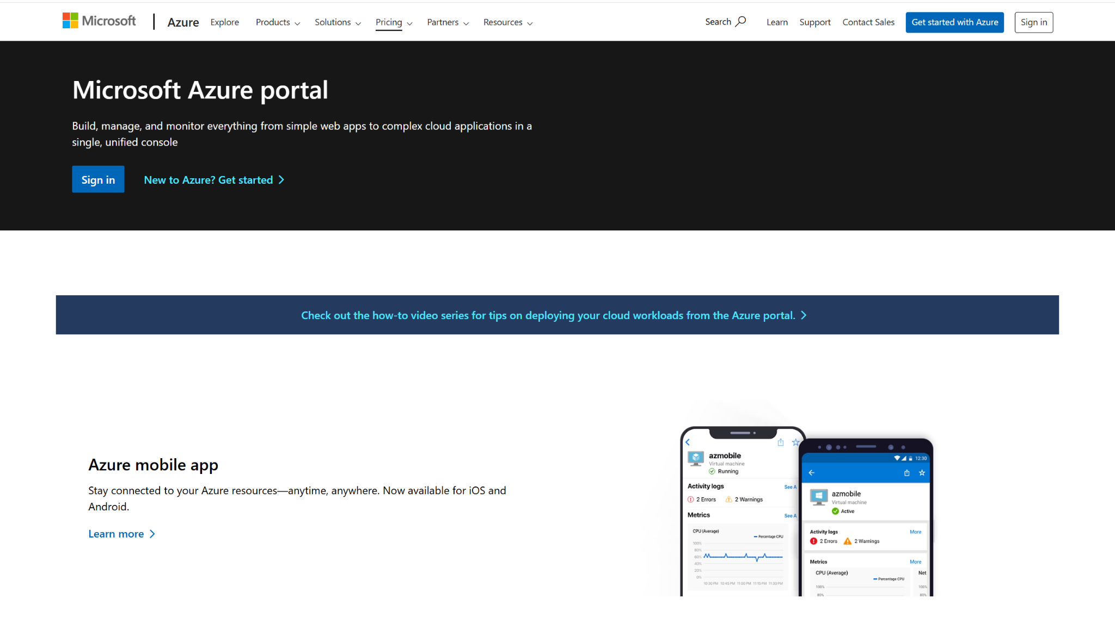

2.Azure home page

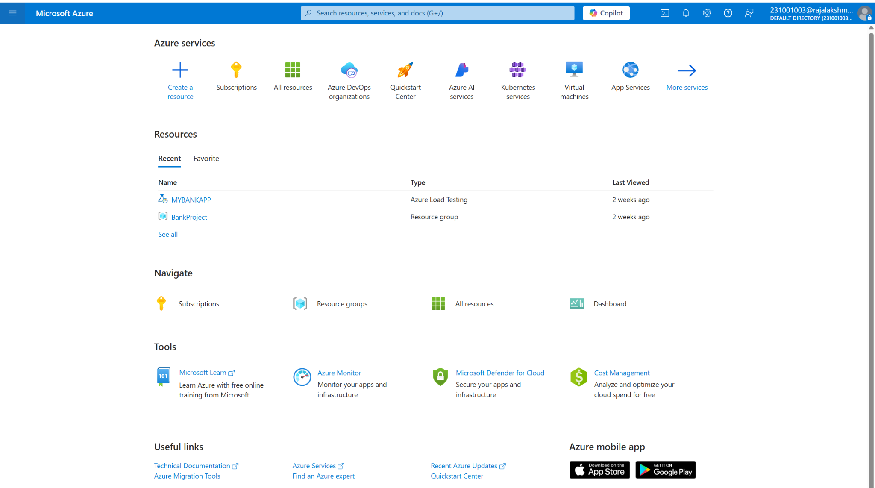

3.Open DevOps environment in the Azure platform by typing ***Azure DevOps Organizations*** in the search bar. 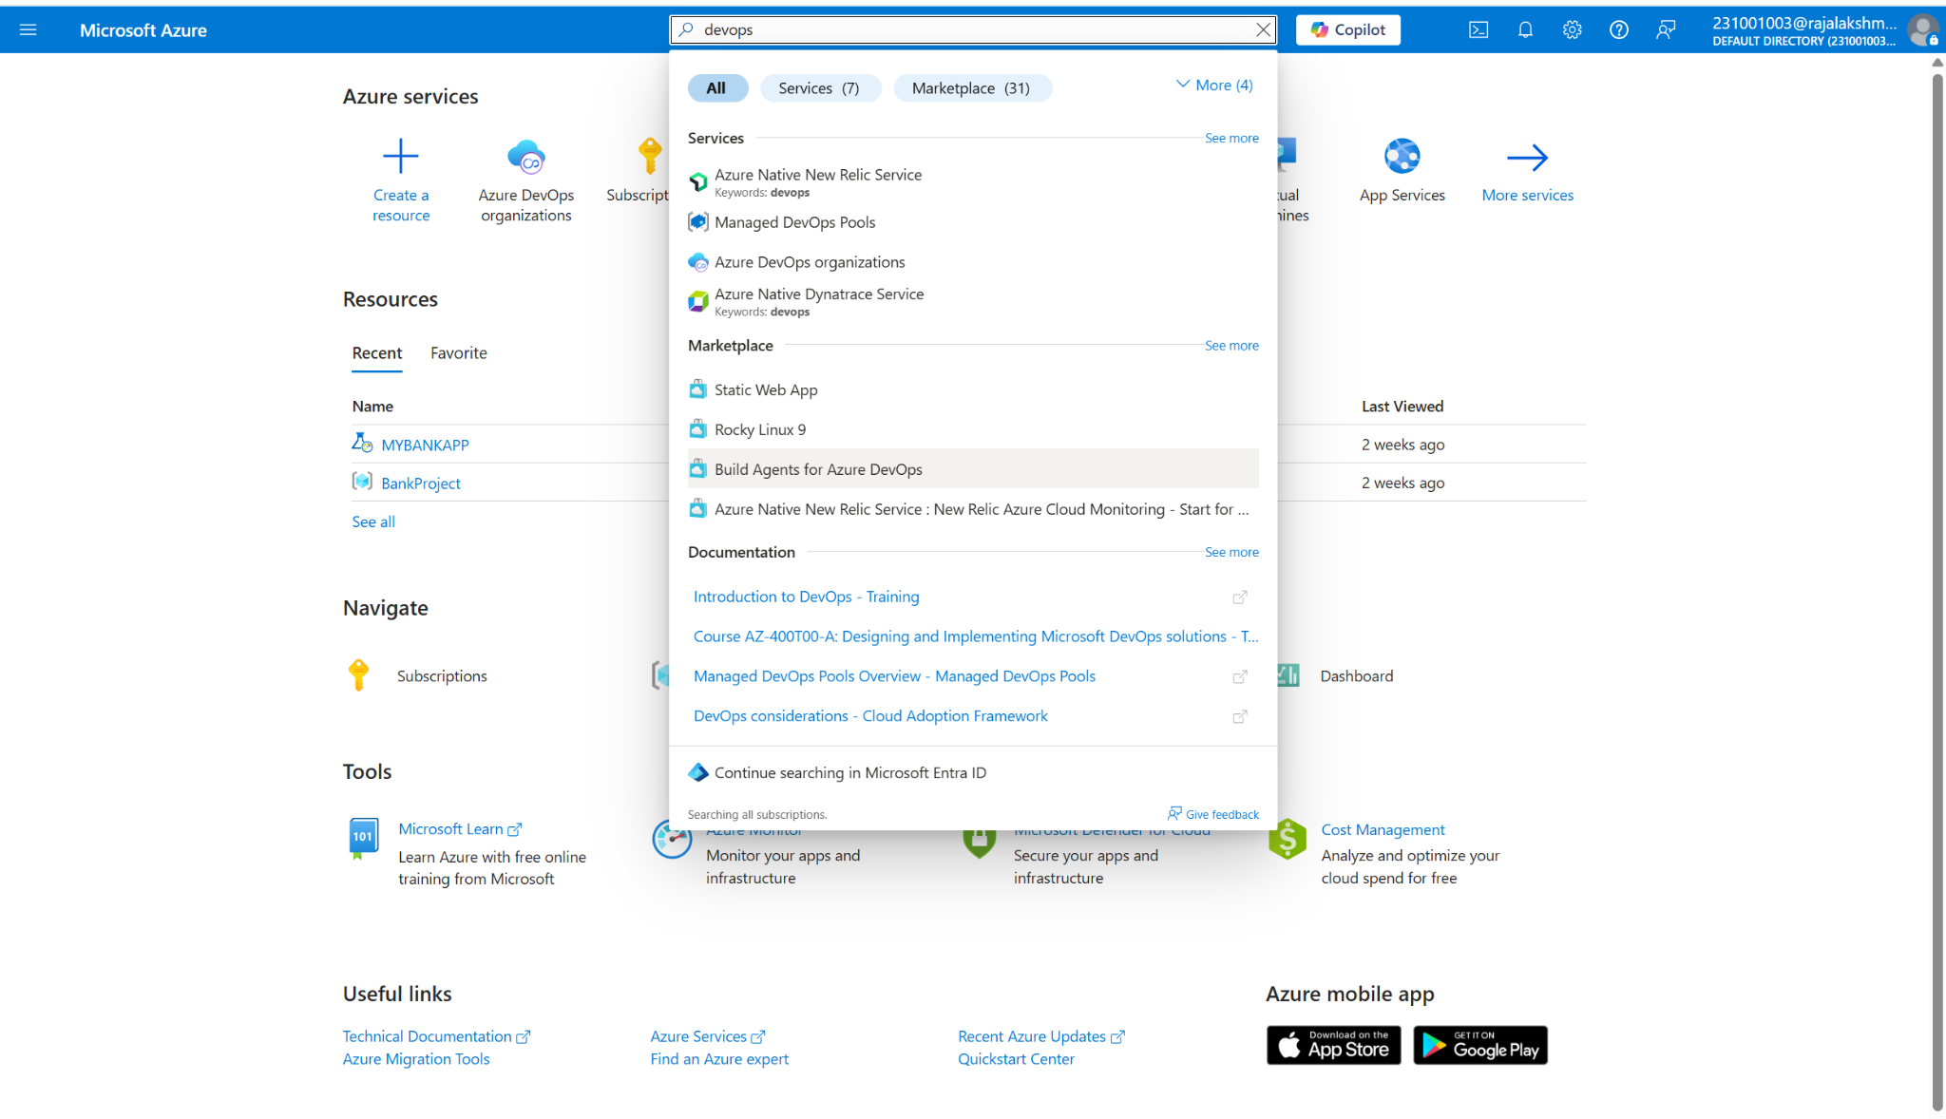

4.Click on the ***My Azure DevOps Organization*** link and create an organization and you should be taken to the Azure DevOps Organization Home page.

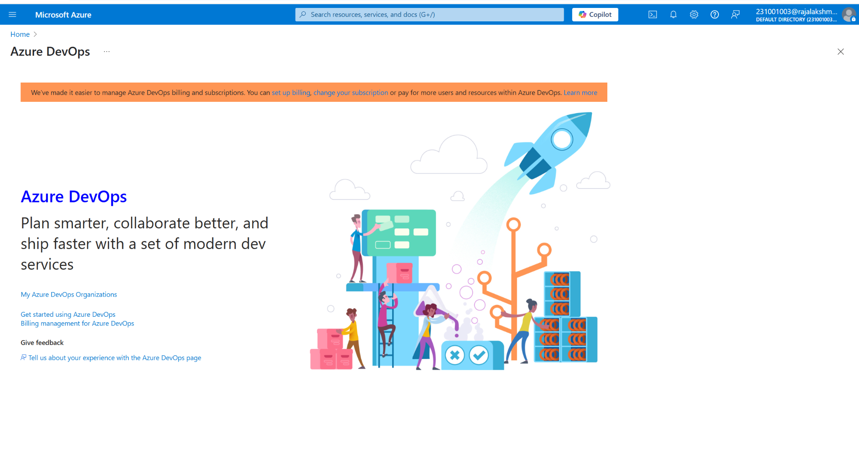

**RESULT:** Successfully accessed the Azure DevOps environment and created a new organization through the Azure portal.

| **Exp.No: 2** | **AZURE DEVOPS PROJECT SET UP AND USER STORY MANAGEMENT** |
| --- | --- |
| **Date: 07/02/2025** |

**AIM:** To set up an Azure DevOps project for efficient collaboration and agile work management.

**STEPS:**

1.Create An Azure Account

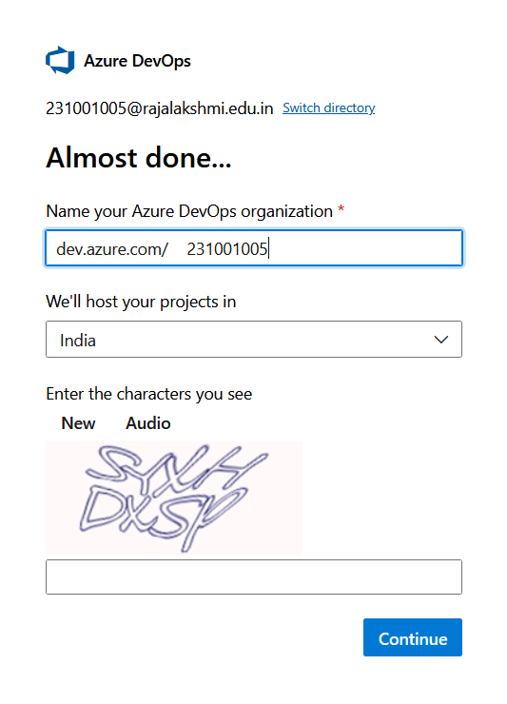

2.Create the First Project in Your Organization

1. After the organization is set up, you’ll need to create your first **project**. This is where you'll

begin to manage code, pipelines, work items, and more.

1. On the organization’s **Home page**, click on the **New Project** button.
2. Enter the project name, description, and visibility options:

***Name****:* Choose a name for the project (e.g., LMS).

***Description****:* Optionally, add a description to provide more context about the project. ***Visibility****:* Choose whether you want the project to be **Private** (accessible only to those invited) or **Public** (accessible to anyone).

1. Once you’ve filled out the details, click **Create** to set up your first project.

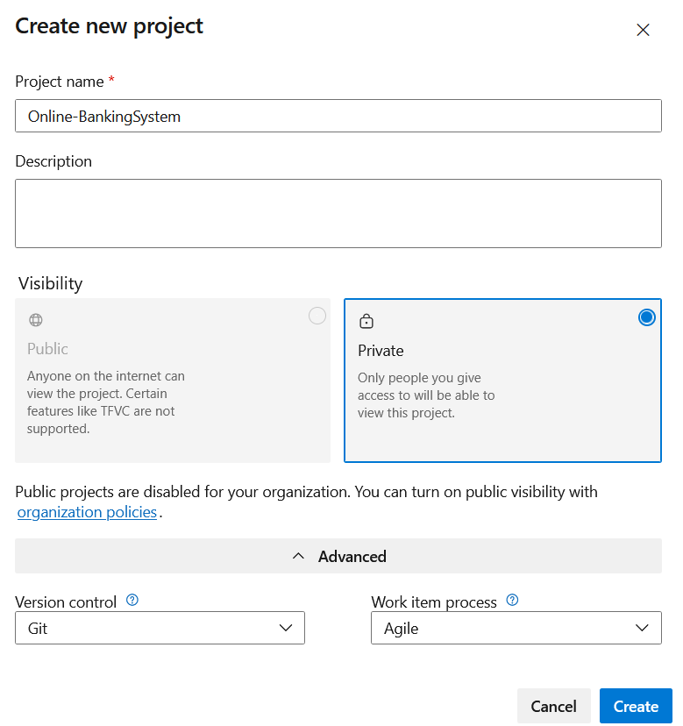

3.Once logged in, ensure you are in the correct organization. If you're part of multiple organizations, you can switch between them from the top left corner (next to your user profile). Click on the Organization name, and you should be taken to the Azure DevOps Organization Home page.

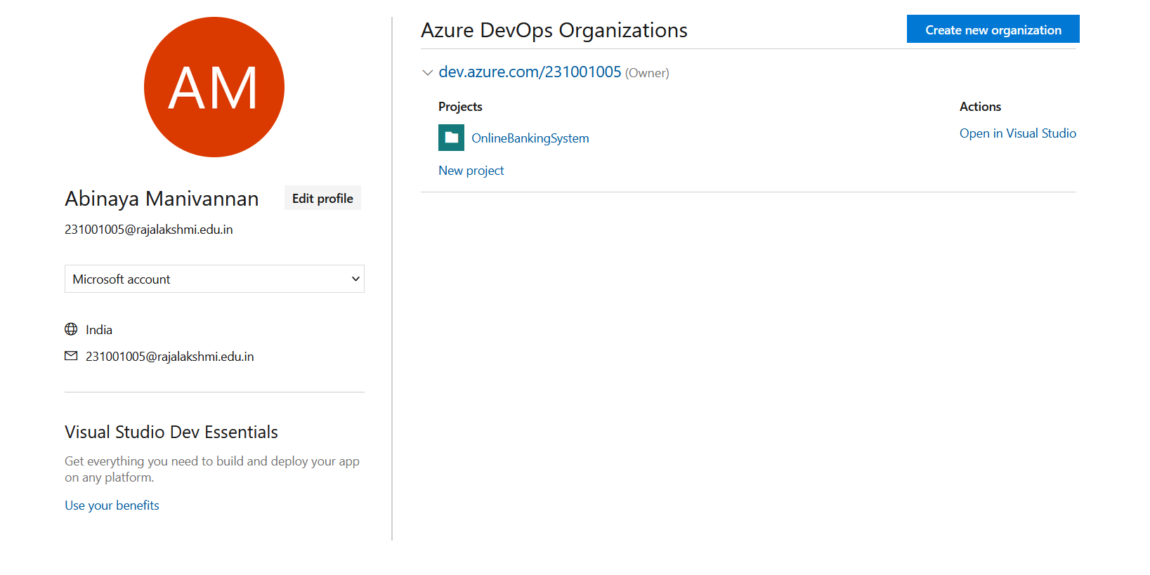

4.Project dashboard

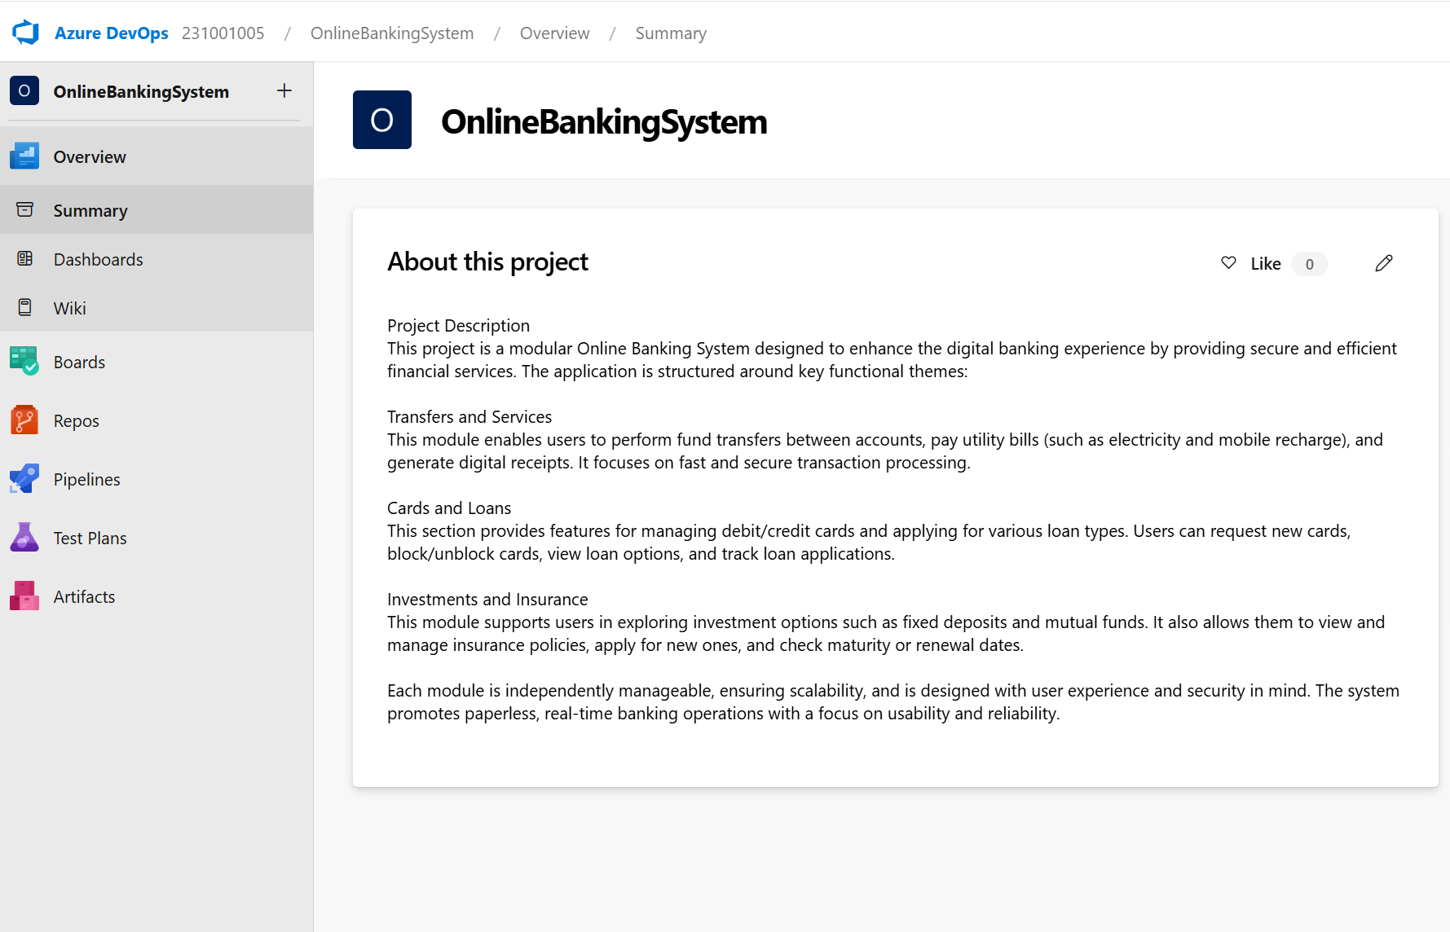

5.To manage user stories:

1. From the **left-hand navigation menu**, click on **Boards**. This will take you to the main **Boards**

page, where you can manage work items, backlogs, and sprints.

1. On the **work items** page, you'll see the option to **Add a work item** at the top. Alternatively,

you can find a **+** button or **Add New Work Item** depending on the view you're in.

From the **Add a work item** dropdown, select **User Story**. This will open a form to enter details

for this user story.

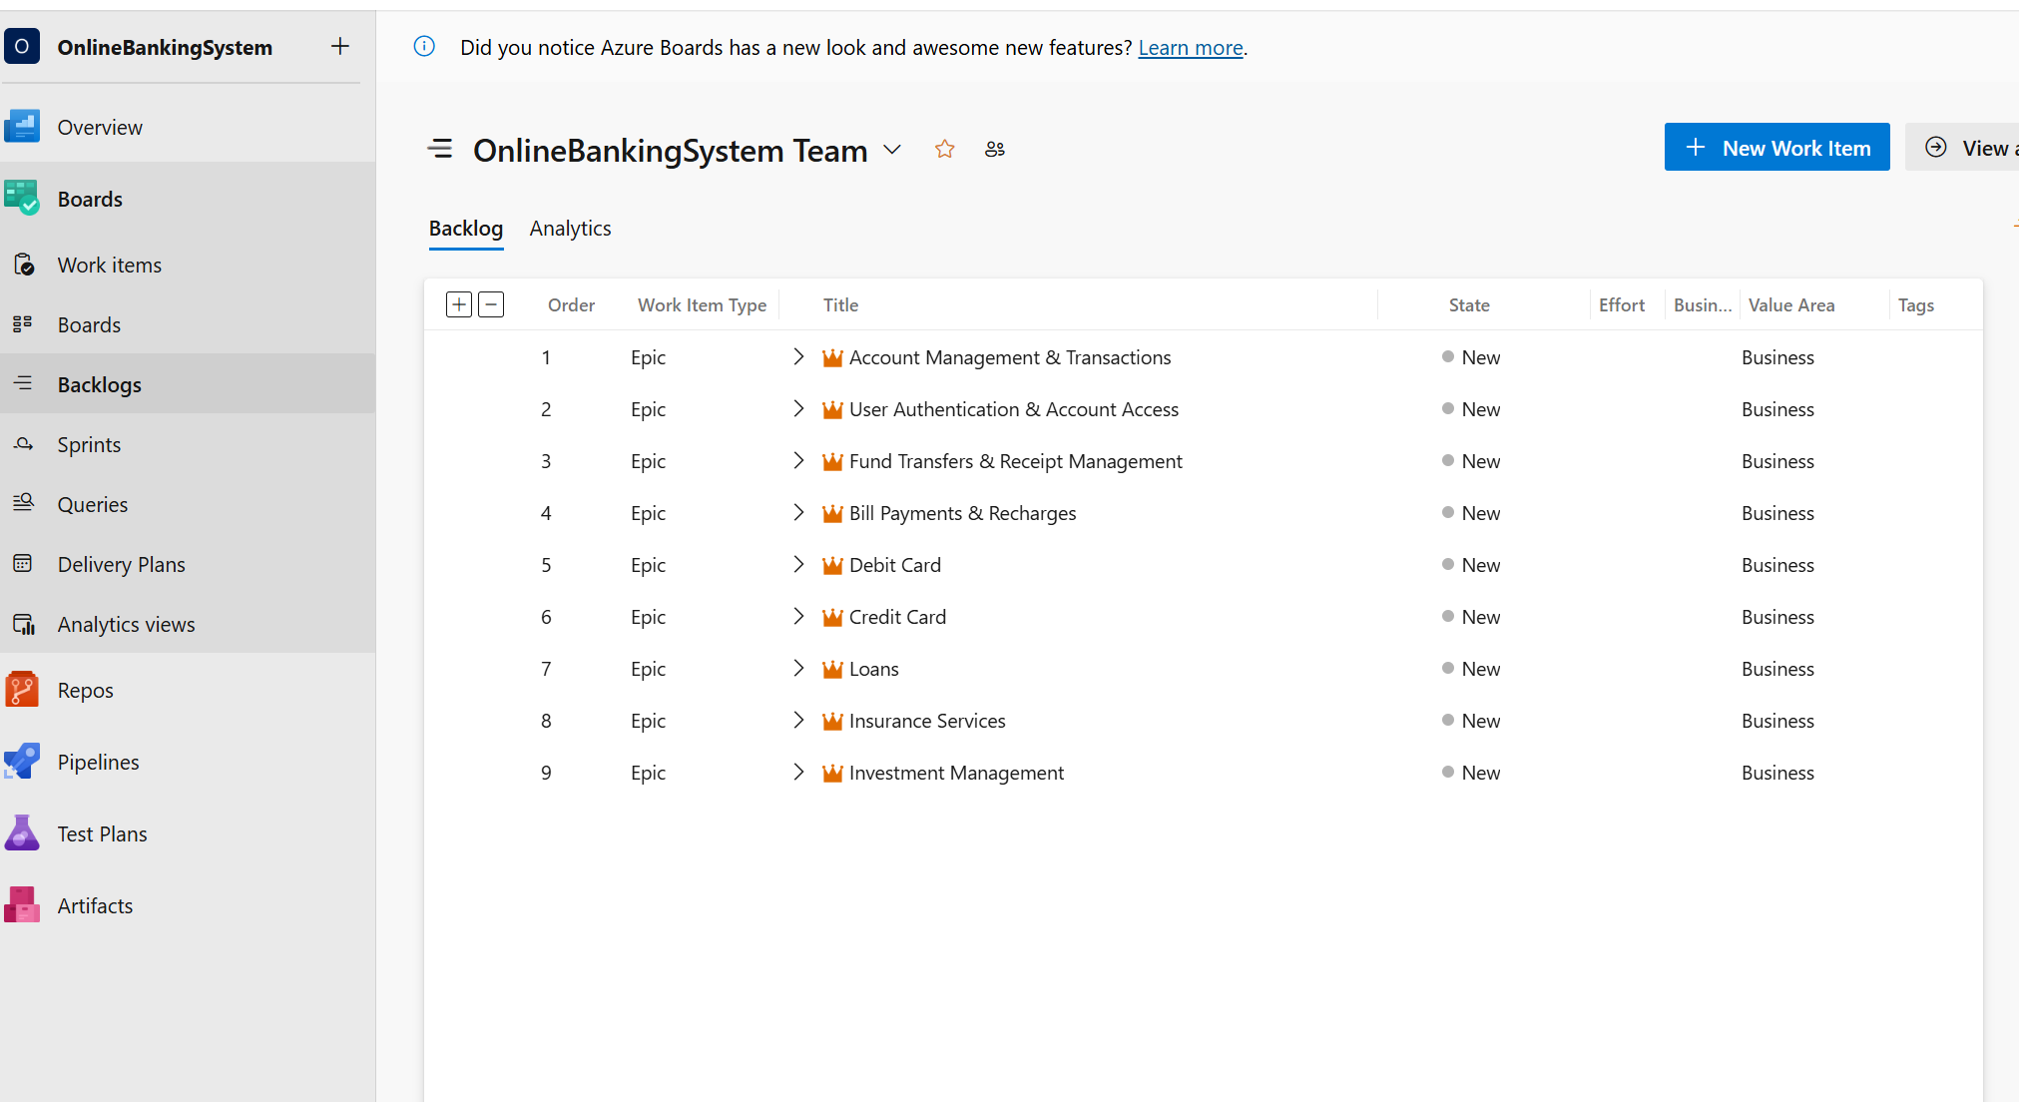

**RESULT:** Successfully created an Azure DevOps project with user story management and agile workflow setup.

| **Exp.No: 3** | **SETTING UP EPICS FEATURES AND USER STORIES FOR PROJECT PLANNING** |
| --- | --- |
| **Date: 14/02/2025** |

**AIM:** To learn about how to create epics, user story, features, backlogs for your assigned project.

# **1.Fill in Epics**

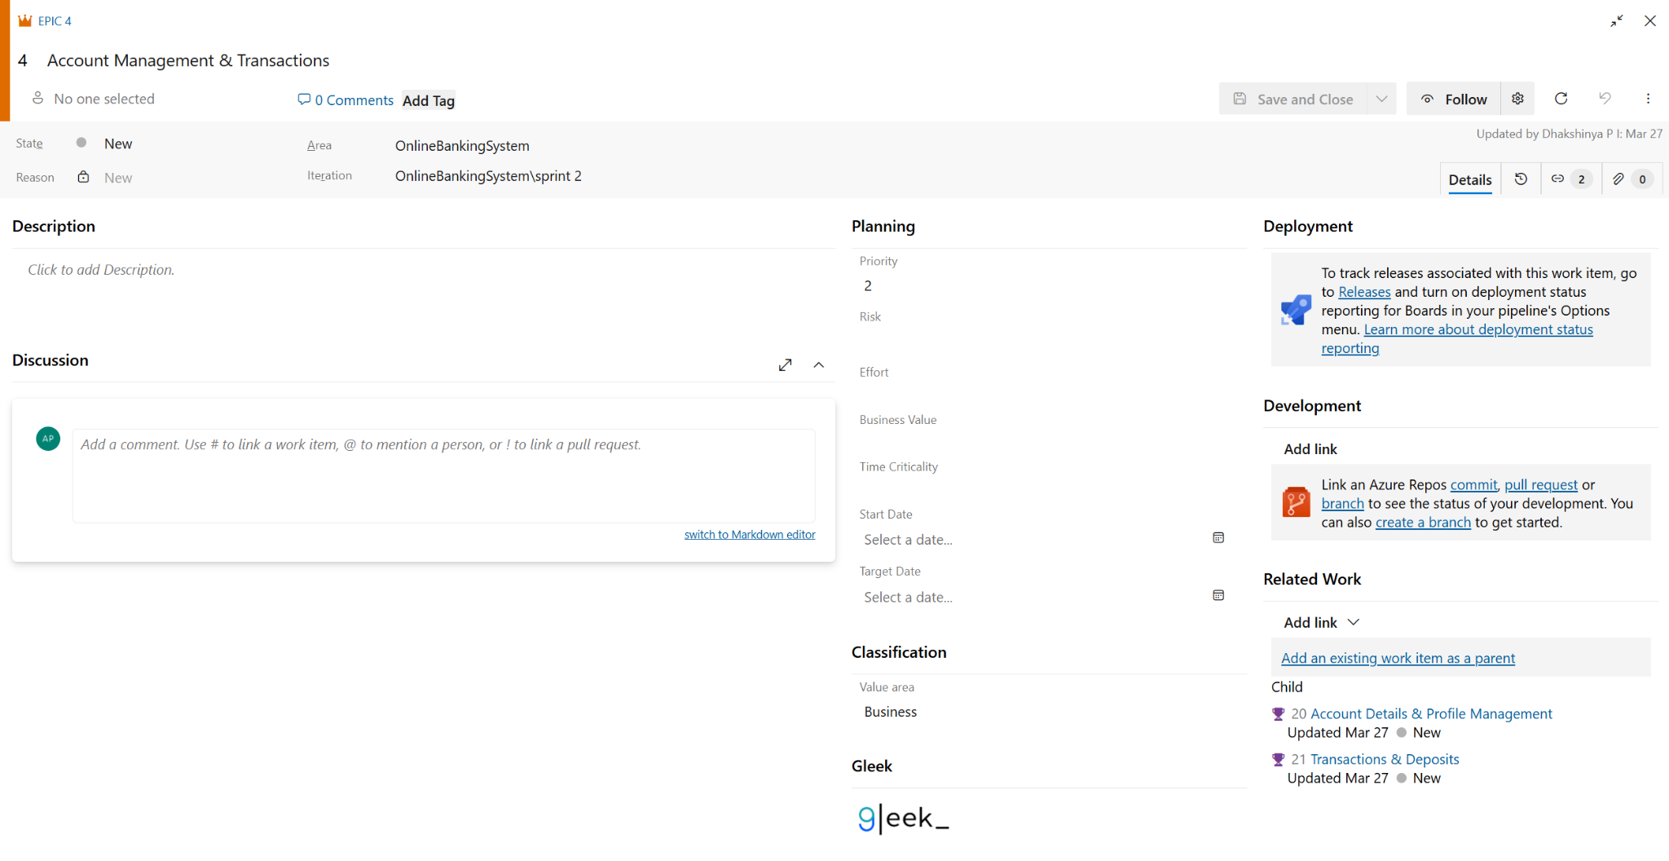

# **2.Fill in Features**

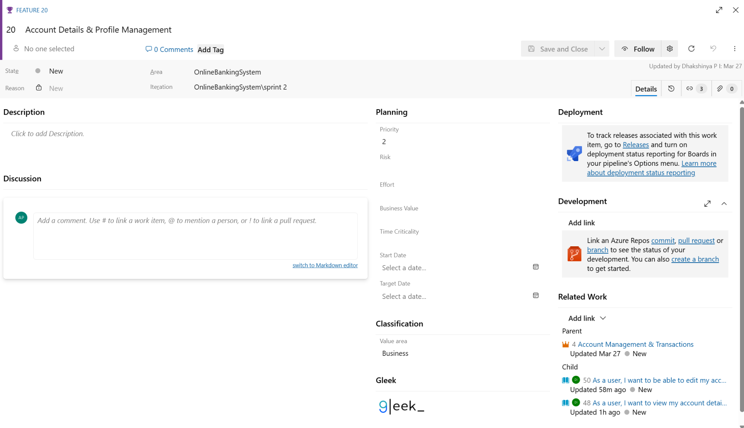

# **3.Fill in User Story Details**

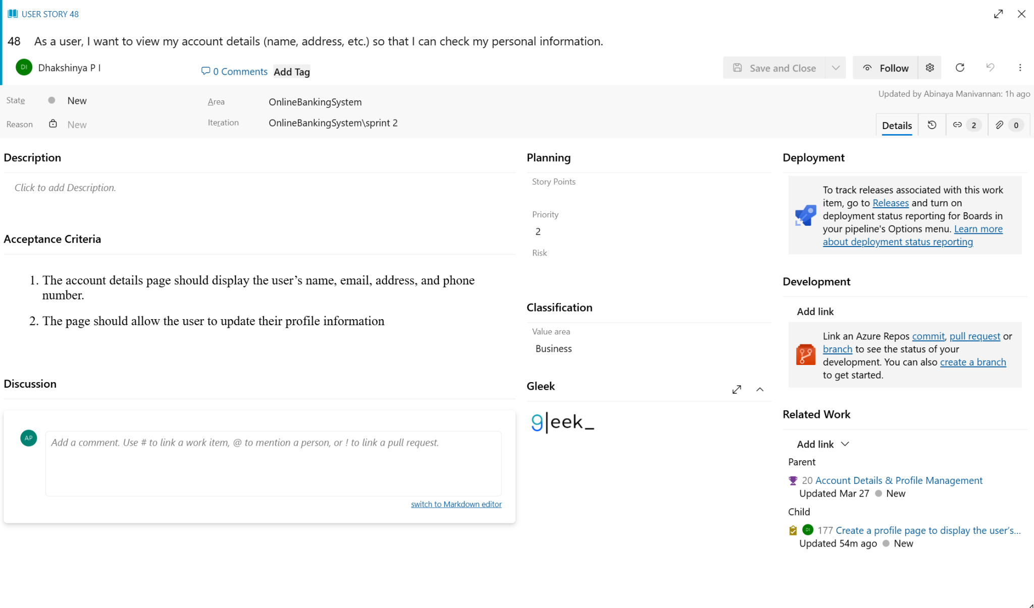

**4.Fill in Task Details**

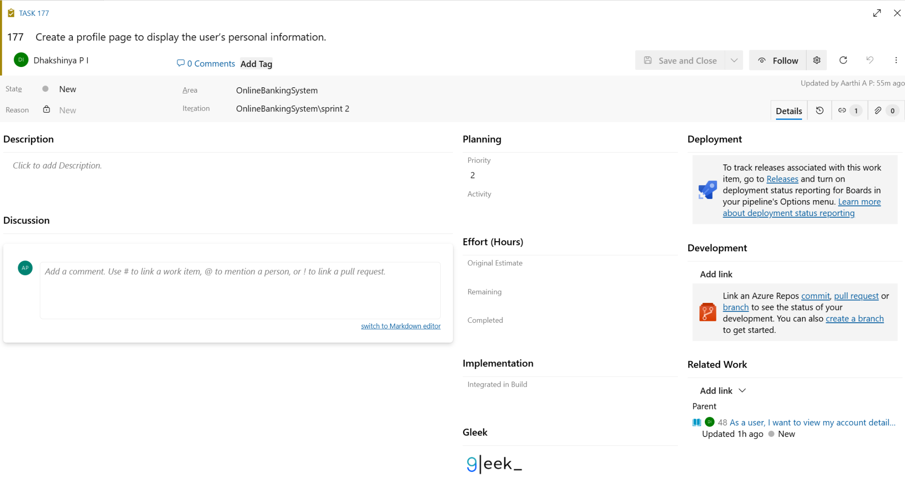

**RESULT:** Thus, the creation of epics, features, user story and task has been created successfully.

| **Exp.No: 4** | **SPRINT PLANNING** |
| --- | --- |
| **Date: 20/03/2025** |

**AIM:** To assign user story to specific sprint for the Online Banking Project.

**SPRINT PLANNING**

**Sprint 1**

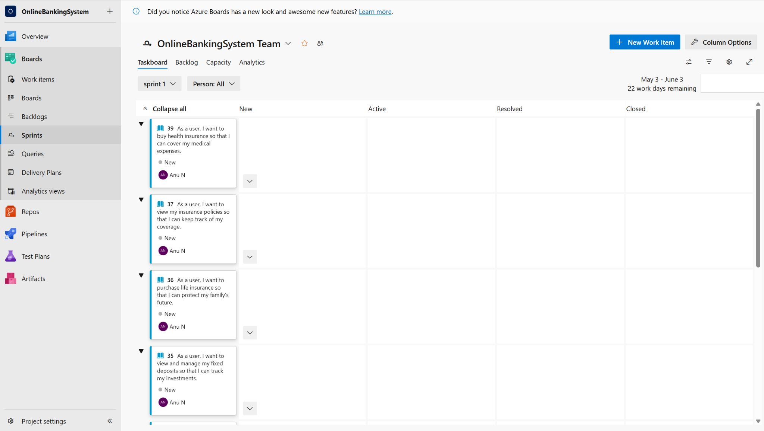

**Sprint 2**

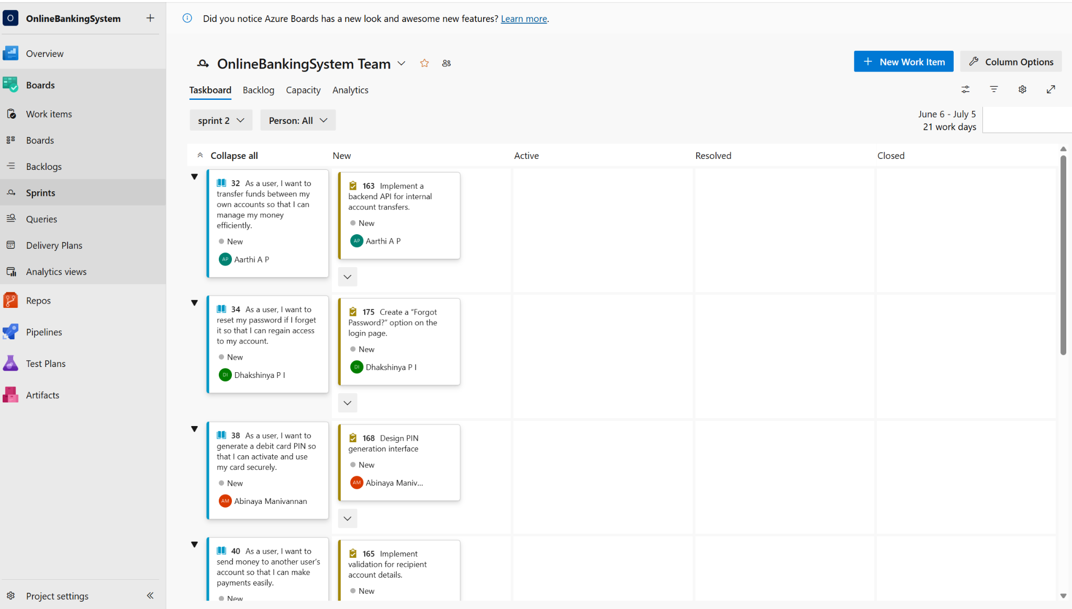

**Sprint 3**

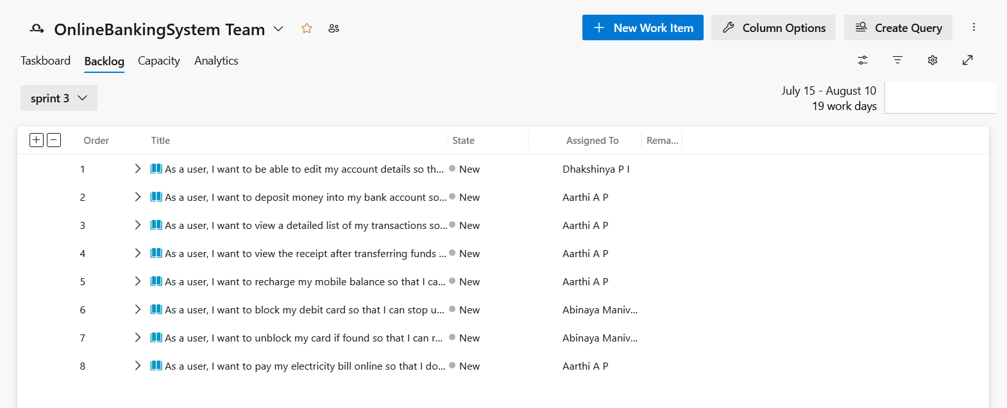

**Sprint 4**

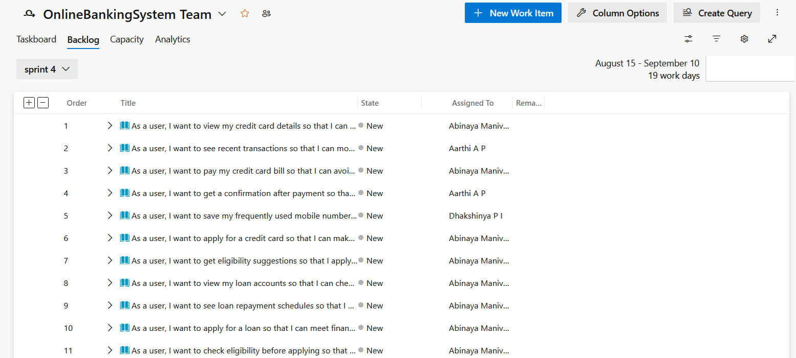

**RESULT:** The Sprints are created for the Online Banking Project.

| **Exp.No: 5** | **POKER ESTIMATION** |
| --- | --- |
| **Date: 28/03/2025** |

**AIM:** Create Poker Estimation for the user stories - Online Banking System Project.

**POKER ESTIMATION**

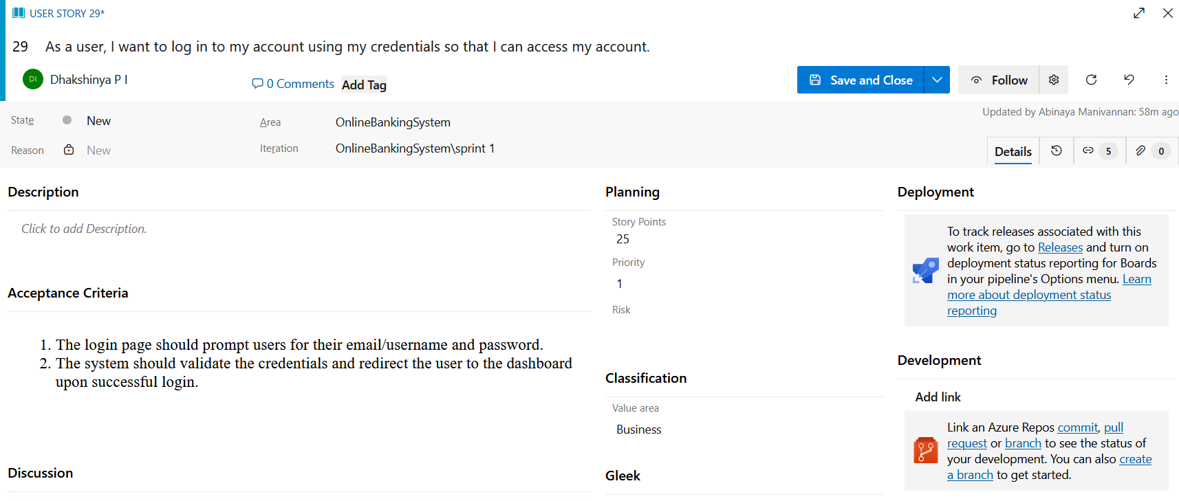

**RESULT:** The Estimation/Story Points is created for the project using Poker Estimation.

| **Exp.No: 6** | **DESIGNING CLASS AND SEQUENCE DIAGRAMS FOR PROJECT ARCHITECTURE** |
| --- | --- |
| **Date: 04/04/2025** |

**AIM:** To Design a Class Diagram and Sequence Diagram for the given Project.

**6A. CLASS DIAGRAM**

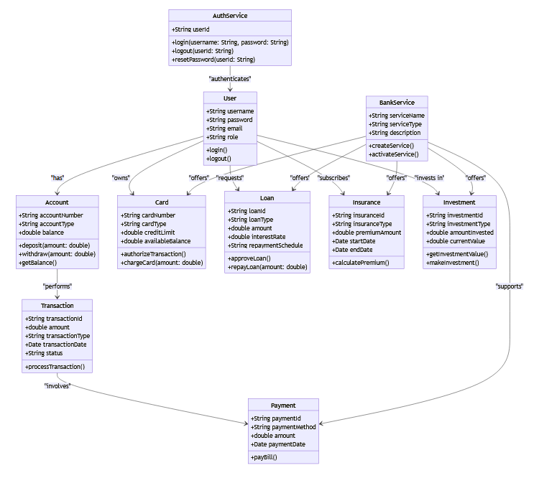

**6B. SEQUENCE DIAGRAM**

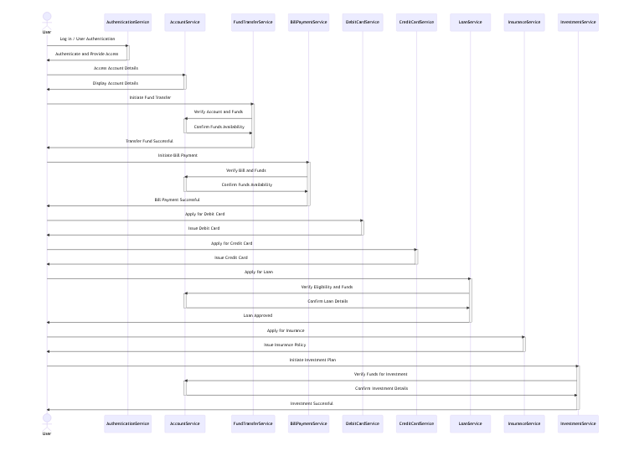

**RESULT:** The Class Diagram and Sequence Diagram is designed Successfully for the Online Banking System.

| **Exp.No: 7** | **DESIGNING ARCHITECTURAL AND ER DIAGRAMS FOR PROJECT STRUCTURE** |
| --- | --- |
| **Date: 16/04/2025** |

**AIM:** To Design an Architectural Diagram and ER Diagram for the given Project.

**7A. ARCHITECTURAL DIAGRAM**

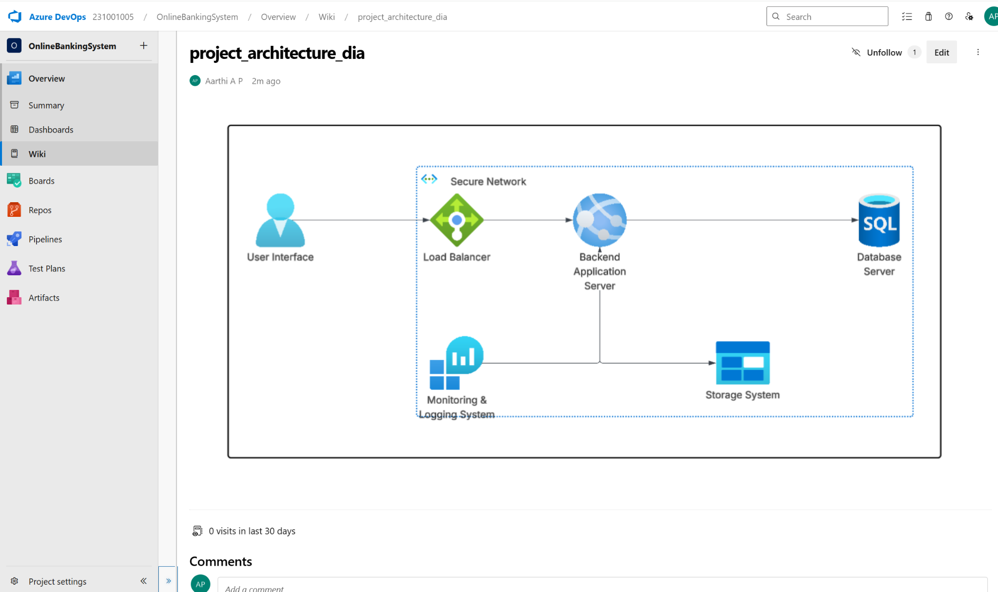

**7B. ER DIAGRAM**

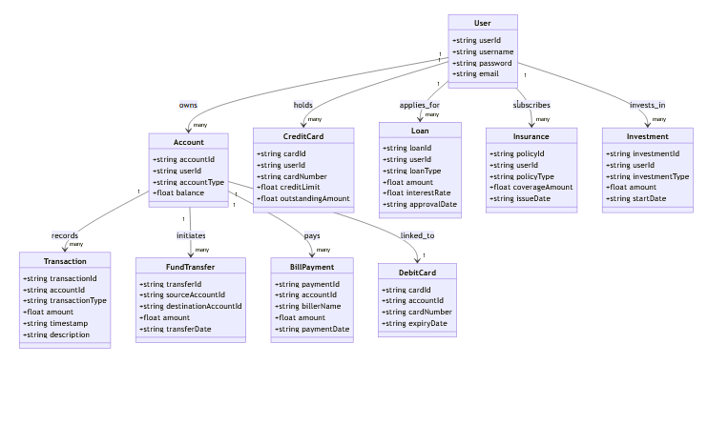

**RESULT:** The Architecture Diagram and ER Diagram is designed Successfully for the Online Banking System.

| **Exp.No: 8** | **TESTING-TEST PLANS AND TEST CASES** |
| --- | --- |
| **Date: 18/04/2025** |

**AIM:** Test Plans and Test Case and write two test cases for at least five user stories showcasing the happy path and error scenarios in azure DevOps platform.

**TEST PLANNING AND TEST CASE**

**Test Case Design Procedure**

### 1. Understand Core Features of the Application

* User Authentication (Login, Forgot Password, MFA)
* Internal & External Fund Transfers
* Mobile Recharge and Bill Payments
* Debit/Credit Card Management (PIN generation, block/unblock, view)
* Loan and Insurance Services
* Investment Options (Mutual Funds, FDs)
* Account Dashboard (Balance, Transactions)

### 2. Define User Interactions

Each test case reflects realistic user actions:

* Logging in securely
* Transferring funds to own or others’ accounts
* Paying bills or recharging mobiles
* Blocking cards when lost
* Applying for loans or insurance

### 3. Design Happy Path Test Cases

* Focused on successful flows where inputs are valid and systems behave as expected.
* Examples:  
  + User logs in with valid credentials
  + Transfers funds successfully
  + Views loan schedule or maturity details

### 4. Design Error Path Test Cases

* Focused on handling invalid, missing, or unexpected inputs.
* Examples:  
  + Login fails due to incorrect password
  + Fund transfer fails due to insufficient balance
  + Card unblock denied without authentication

5. Break Down Steps and Expected Results

Each test case includes:

* Clear step-by-step actions
* Specific expected results for each step  
   This ensures reproducibility and easy automation later.

### 6. Use Clear Naming and IDs

* Example:  
  + TC01 – Login with Valid Credentials
  + TC05 – Fund Transfer Blocked (Insufficient Balance)
  + TC11 – Credit Card Bill Payment Successful
* Helps trace test cases to user stories and features in Azure DevOps

### 7. Separate Test Suites

Organize test cases based on functional modules:

* TS01 – User Authentication
* TS02 – Fund Transfers & Recharges
* TS03 – Cards & Loans
* TS04 – Investments & Insurance
* TS05 – Account Management & Security

**1.New test plan**

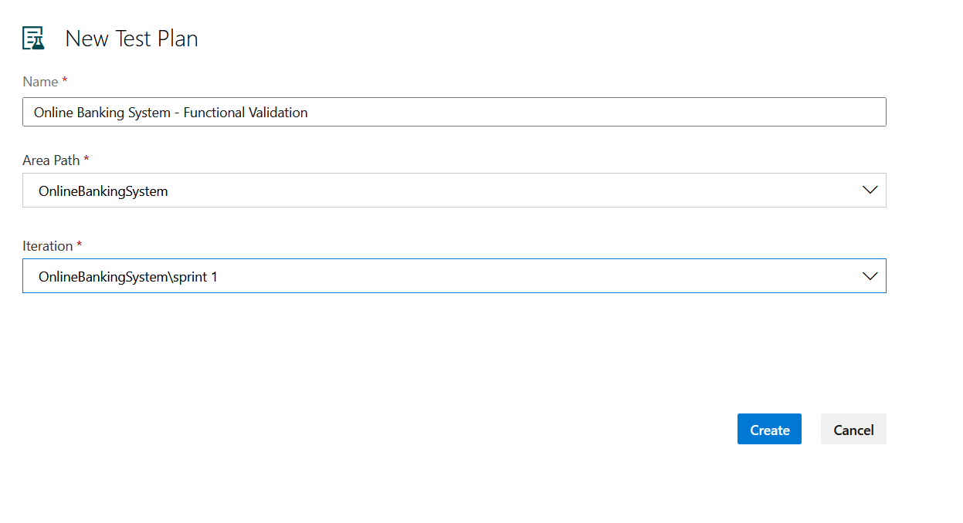

**2.Test suite**

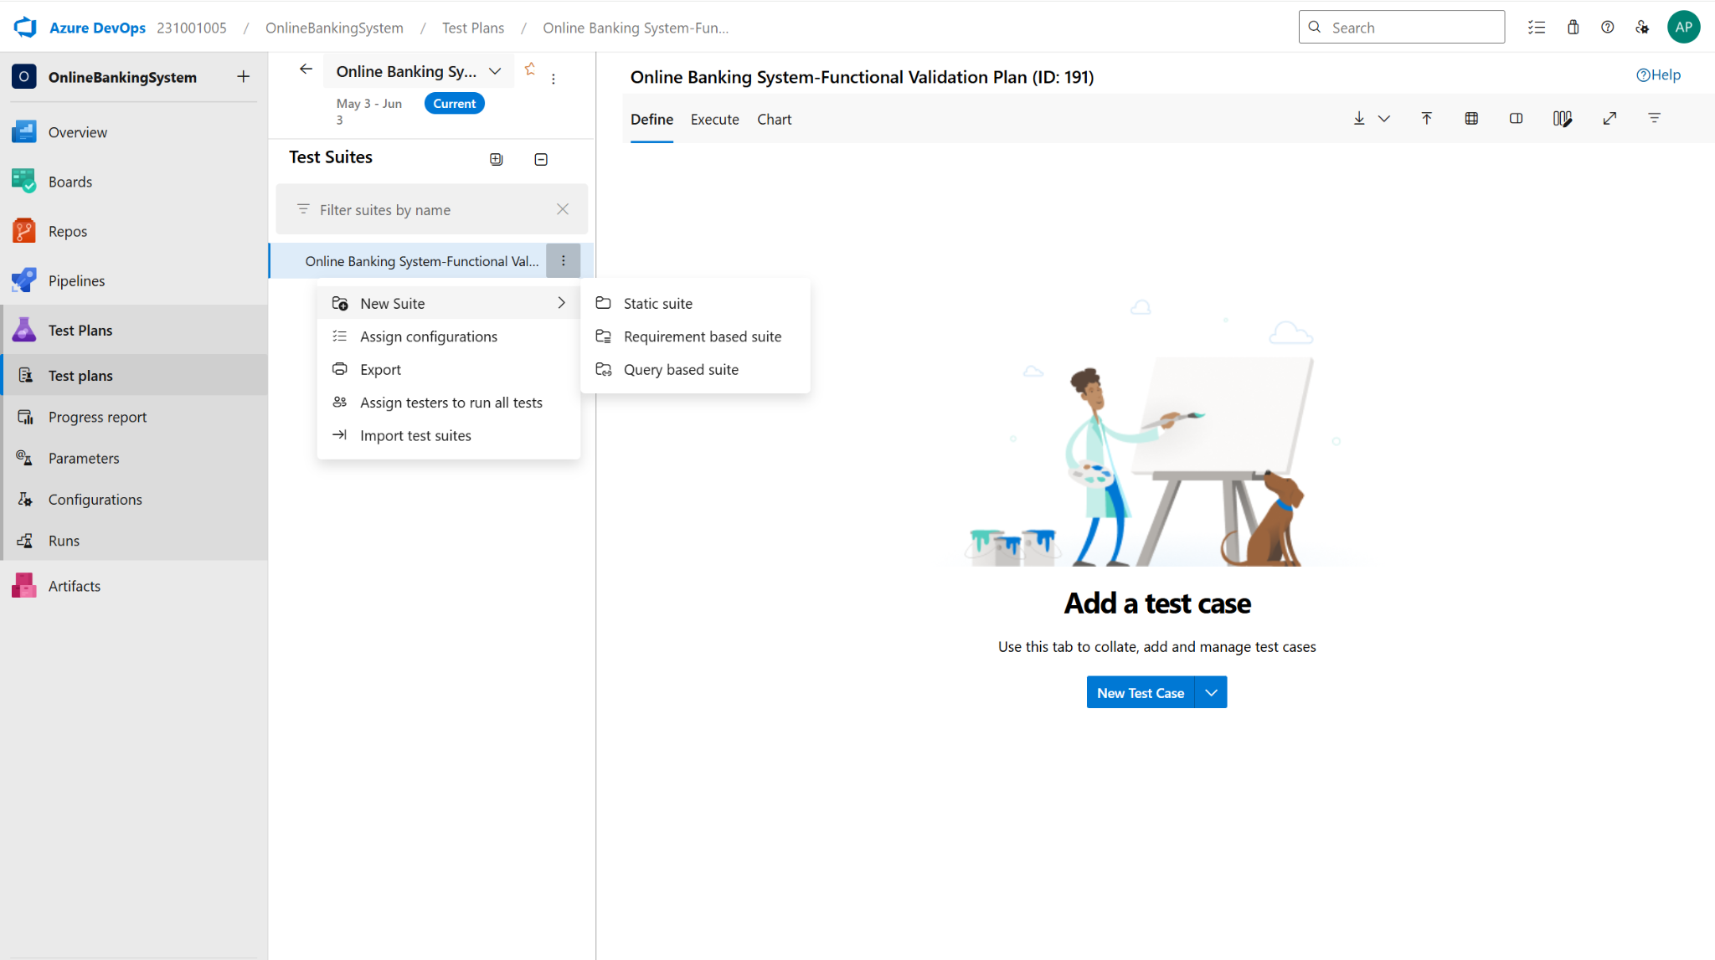

**3.Test case**

Give two test cases for at least five user stories showcasing the happy path and error scenarios in azure DevOps platform.

Online Banking System– Test Plans

### **User Stories – Banking Application**

* **US199**: As a user, I want to securely log in to my bank account so I can view and manage my finances.
* **US200**: As a user, I want to transfer funds between my own accounts so that I can manage my money efficiently.
* **US196**: As a user, I want to generate a debit card PIN so that I can activate and use my card securely.
* **US198**: As a user, I want to open a fixed deposit so that I can earn guaranteed returns.
* **US201**: As a user, I want to pay my credit card bill so that I can avoid penalties.

**TEST SUITE: TS01 – USER LOGIN (ID: 199)**

**Test Case: TC01 – Login with Valid Credentials  
User Story**: As a user, I want to securely log in to my bank account so I can view and manage my finances.  
**Test Type**: Happy Path

**Steps and Expected Results:**

* **Action**: Navigate to the login page  
  **Expected Result**: Login page is displayed with username and password fields
* **Action**: Enter valid username and password  
  **Expected Result**: Input is accepted with no errors
* **Action**: Click the "Login" button  
  **Expected Result**: User is redirected to the account dashboard

**Notes:** Ensure the test user has an active bank account. This test simulates a successful login.

**Test Case: TC02 – Login with Invalid Password  
User Story**: As a user, I want to securely log in to my bank account so I can view and manage my finances.  
**Test Type**: Error Path

**Steps and Expected Results:**

* **Action**: Navigate to the login page  
  **Expected Result**: Login page is displayed
* **Action**: Enter valid username and incorrect password  
  **Expected Result**: Password is rejected
* **Action**: Click the "Login" button  
  **Expected Result**: Error message “Incorrect password” is shown

**Notes:** Ensures failed login attempts are handled gracefully with proper error messages.

**TEST SUITE: TS02 – FUND TRANSFER (ID: 200)**

**Test Case: TC01 – Fund Transfer with Valid Inputs  
User Story**: As a user, I want to transfer funds between my own accounts so that I can manage my money efficiently.  
**Test Type**: Happy Path

**Steps and Expected Results:**

* **Action**: Log in and go to the "Fund Transfer" section  
  **Expected Result**: Fund Transfer page is displayed
* **Action**: Select source and destination accounts, enter valid amount  
  **Expected Result**: Amount is accepted; no validation error
* **Action**: Click "Transfer" and confirm the transaction  
  **Expected Result**: Success message is shown and balances are updated

**Test Case: TC02 – Fund Transfer with Insufficient Balance  
User Story**: As a user, I want to transfer funds between my own accounts so that I can manage my money efficiently.  
**Test Type**: Error Path

**Steps and Expected Results:**

* **Action**: Log in and go to the "Fund Transfer" section  
  **Expected Result**: Fund Transfer page is displayed
* **Action**: Select source account with low balance, enter transfer amount greater than available balance  
  **Expected Result**: Validation error or warning message is shown (e.g., "Insufficient balance")
* **Action**: Click "Transfer" and try to proceed  
  **Expected Result**: Transaction is blocked, no funds are deducted

**TEST SUITE: TS03 – GENERATE DEBIT CARD PIN (ID: 196)**

**Test Case: TC01 – Generate Debit Card PIN Successfully  
User Story**: As a user, I want to generate a debit card PIN so that I can activate and use my card securely.  
**Test Type**: Happy Path

**Steps and Expected Results:**

* **Action**: Log in to the system and navigate to the "Generate Debit Card PIN" section  
  **Expected Result**: The user is successfully logged in, and the "Generate Debit Card PIN" page or section is displayed
* **Action**: Enter the required card details (e.g., card number, expiry date), a new 4-digit PIN, and re-enter the same PIN for confirmation  
  **Expected Result**: The system accepts the card details and both PIN entries without immediate error. The new and confirmation PIN entries should match
* **Action**: Click on "Generate PIN" and observe the system feedback  
  **Expected Result**: The system initiates PIN generation and displays a success message: “Debit card PIN generated successfully.”

**Test Case: TC02 – Generate Debit Card PIN with Mismatched Entries  
User Story**: As a user, I want to generate a debit card PIN so that I can activate and use my card securely.  
**Test Type**: Error Path

**Steps and Expected Results:**

* **Action**: Log in to the system and navigate to the "Generate Debit Card PIN" section  
  **Expected Result**: The user is successfully logged in, and the "Generate Debit Card PIN" page or section is displayed
* **Action**: Enter the required card details, a new 4-digit PIN, and re-enter a different 4-digit PIN for confirmation  
  **Expected Result**: The system accepts the card details and both PIN entries without immediate error. The new PIN entered in the first instance is different from the confirmation PIN
* **Action**: Click on "Generate PIN" and observe the system feedback  
  **Expected Result**: An error message is displayed indicating that the PINs do not match and the debit card PIN is not generated

**TEST SUITE: TS04 – OPEN FIXED DEPOSIT (ID: 198)**

**Test Case: TC01 – Open Fixed Deposit with Valid Details  
User Story**: As a user, I want to open a fixed deposit so that I can earn guaranteed returns.  
**Test Type**: Happy Path

**Steps and Expected Results:**

* **Action**: Log in to the system and navigate to the "Open Fixed Deposit" section  
  **Expected Result**: The user is successfully logged in, and the "Open Fixed Deposit" page or section is displayed, showing options for deposit type and tenure
* **Action**: Select a deposit type and tenure, enter a valid deposit amount within the allowed range, and select the funding account  
  **Expected Result**: The system accepts the selections and the entered deposit amount without immediate errors. The available funding accounts are displayed for selection
* **Action**: Review the terms and conditions and confirm the fixed deposit creation  
  **Expected Result**: Upon confirmation, a success message is displayed and the details of the newly created fixed deposit are shown or accessible to the user

**Test Case: TC02 – Open Fixed Deposit with Invalid Amount  
User Story**: As a user, I want to open a fixed deposit so that I can earn guaranteed returns.  
**Test Type**: Error Path

**Steps and Expected Results:**

* **Action**: Log in to the system and navigate to the "Open Fixed Deposit" section  
  **Expected Result**: The user is successfully logged in, and the "Open Fixed Deposit" page or section is displayed, showing options for deposit type and tenure
* **Action**: Select a deposit type and tenure, and enter a deposit amount that is below the minimum allowed limit  
  **Expected Result**: The system accepts the deposit type and tenure selections and allows the user to enter the deposit amount
* **Action**: Attempt to proceed with the fixed deposit creation  
  **Expected Result**: The system prevents the creation of the fixed deposit. An error message is displayed to the user indicating that the entered amount is below the minimum allowed limit

**TEST SUITE: TS05 – CREDIT CARD BILL PAYMENT (ID: 201)**

**Test Case: TC01 – Pay Credit Card Bill Successfully**

**User Story**: As a user, I want to pay my credit card bill so that I can avoid penalties.

**Test Type**: Happy Path

**Steps and Expected Results:**

* **Action**: Log in, go to "Credit Card Payment," and select the card  
  **Expected Result**: The user logs in successfully, and the "Credit Card Payment" section displays the user's credit card(s) for selection
* **Action**: Enter a valid payment amount and choose a payment method (e.g., bank account)  
  **Expected Result**: The system accepts the payment amount (within the limit) and displays available payment methods for the user to choose from
* **Action**: Confirm the payment details and click “Pay Now”  
  **Expected Result**: A success message appears ("Credit card bill payment successful."), and the credit card balance is updated to reflect the payment

**Test Case: TC02 – Pay Credit Card Bill with Excess Amount  
User Story**: As a user, I want to pay my credit card bill so that I can avoid penalties.  
**Test Type**: Error Path

**Steps and Expected Results:**

* **Action**: Log in, go to "Credit Card Payment," and select the card  
  **Expected Result**: The user logs in successfully, and the "Credit Card Payment" section displays the user's credit card(s) for selection
* **Action**: Enter a payment amount that is greater than the displayed outstanding balance  
  **Expected Result**: The system accepts the entered amount. It might immediately show a warning or allow proceeding to the next step
* **Action**: Attempt to proceed with the payment  
  **Expected Result**: The system prevents processing the payment. An error or warning message is shown

**Test Cases**

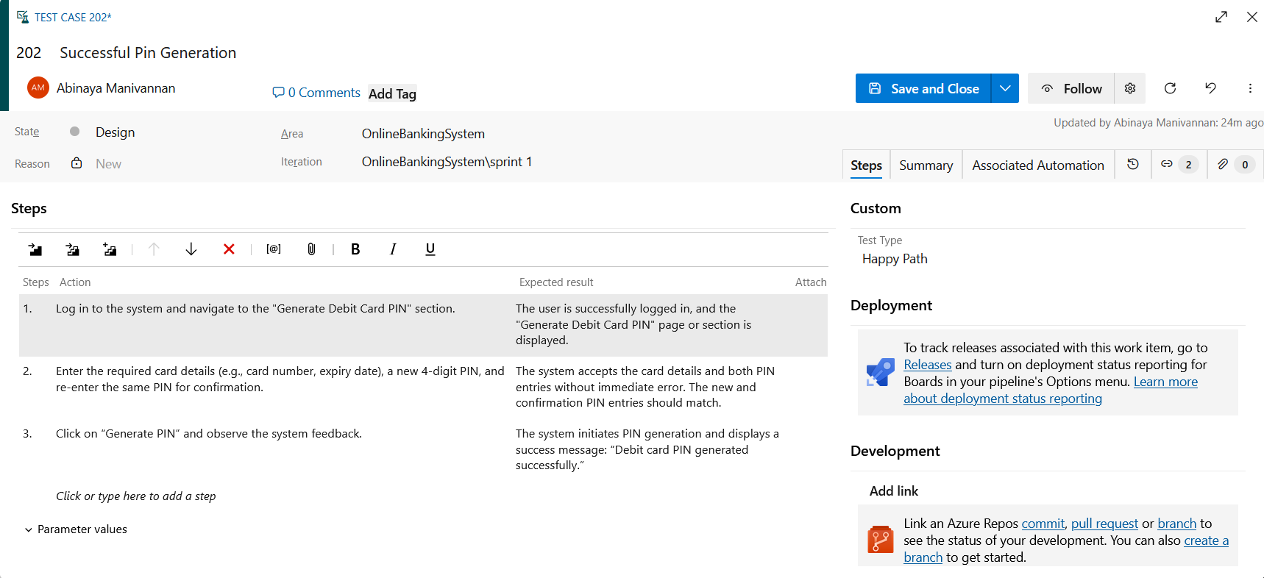

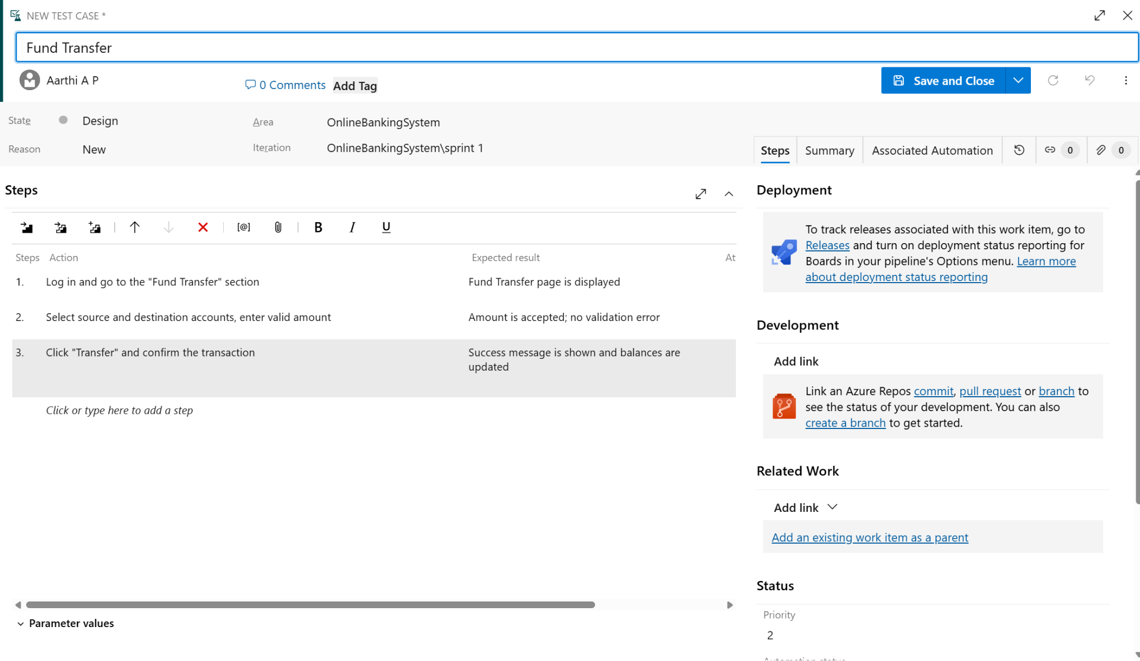

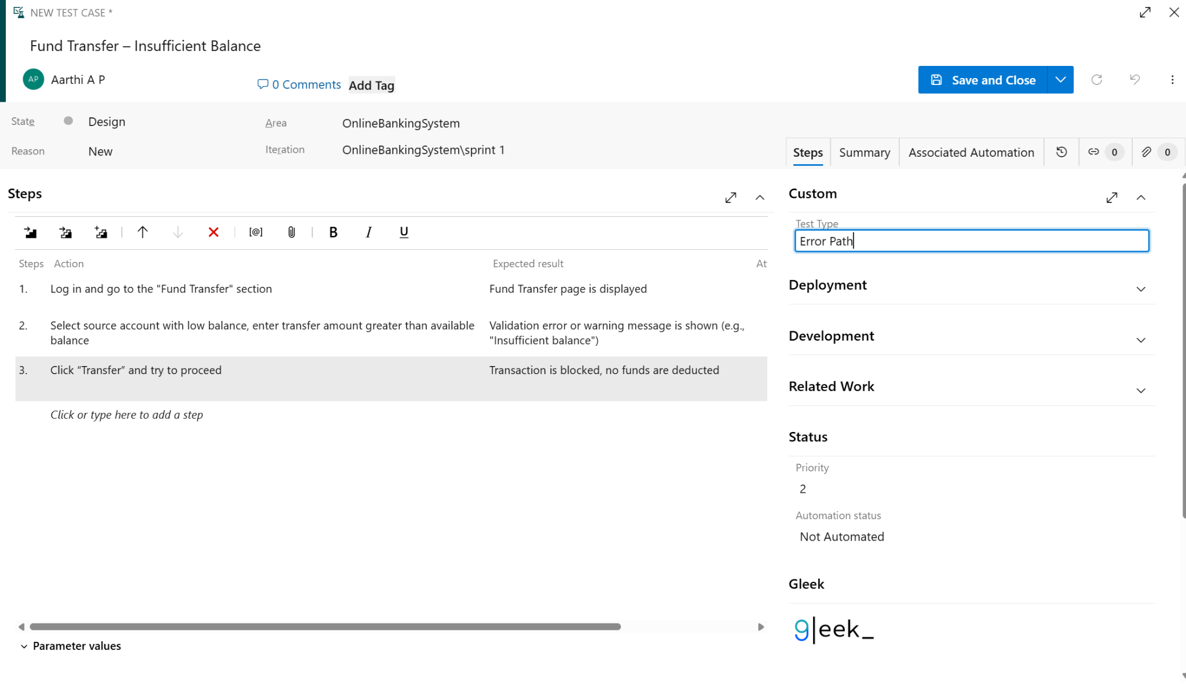

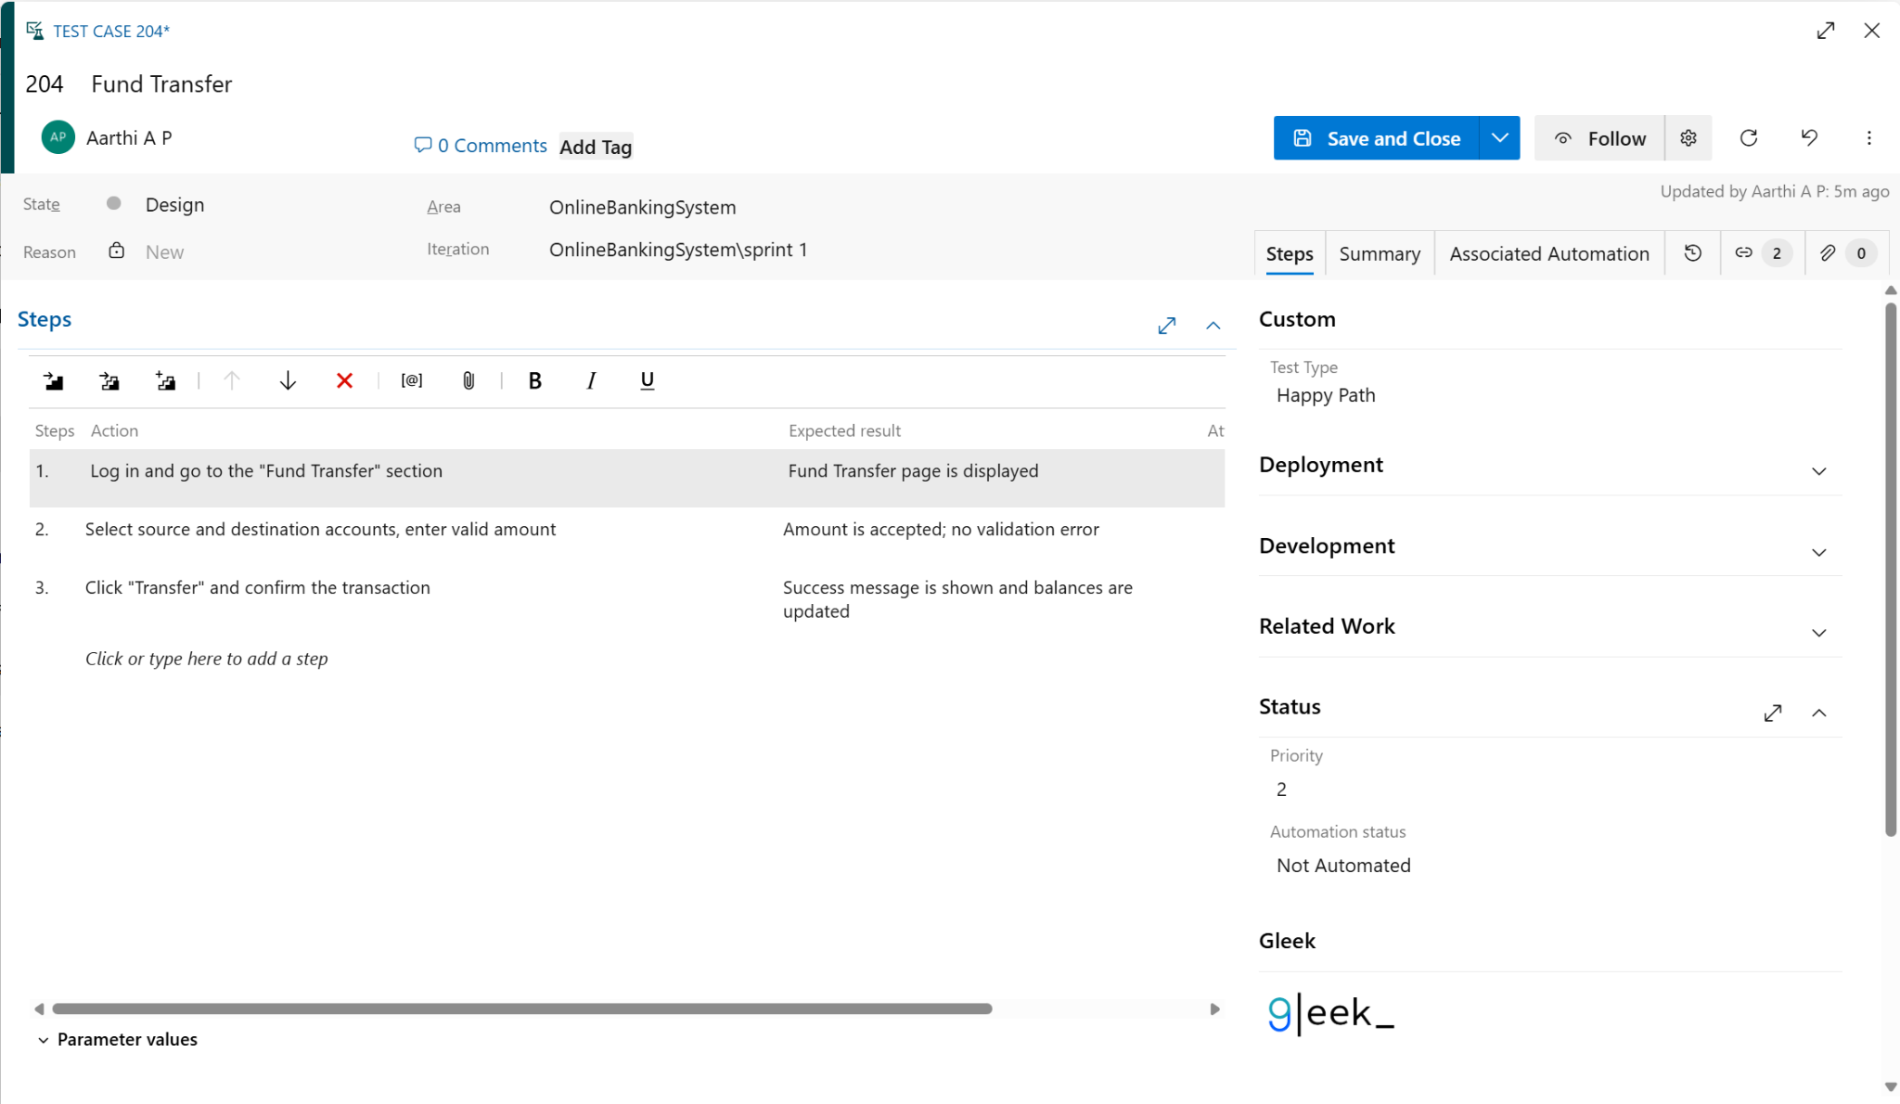

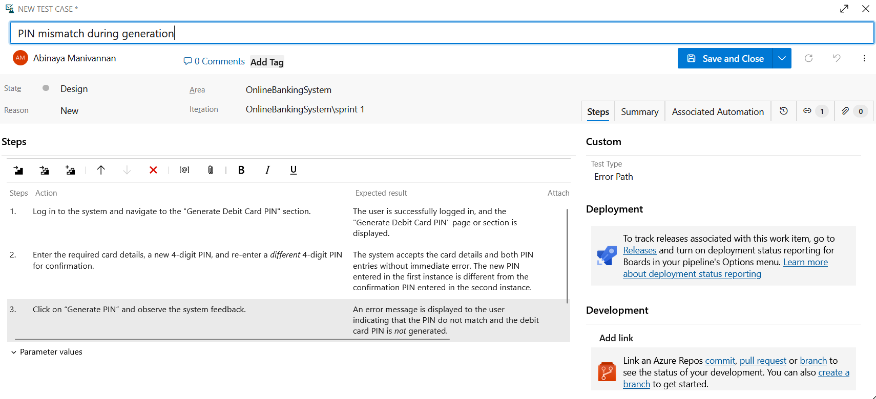

**4.Installation of test**

Test and feedback

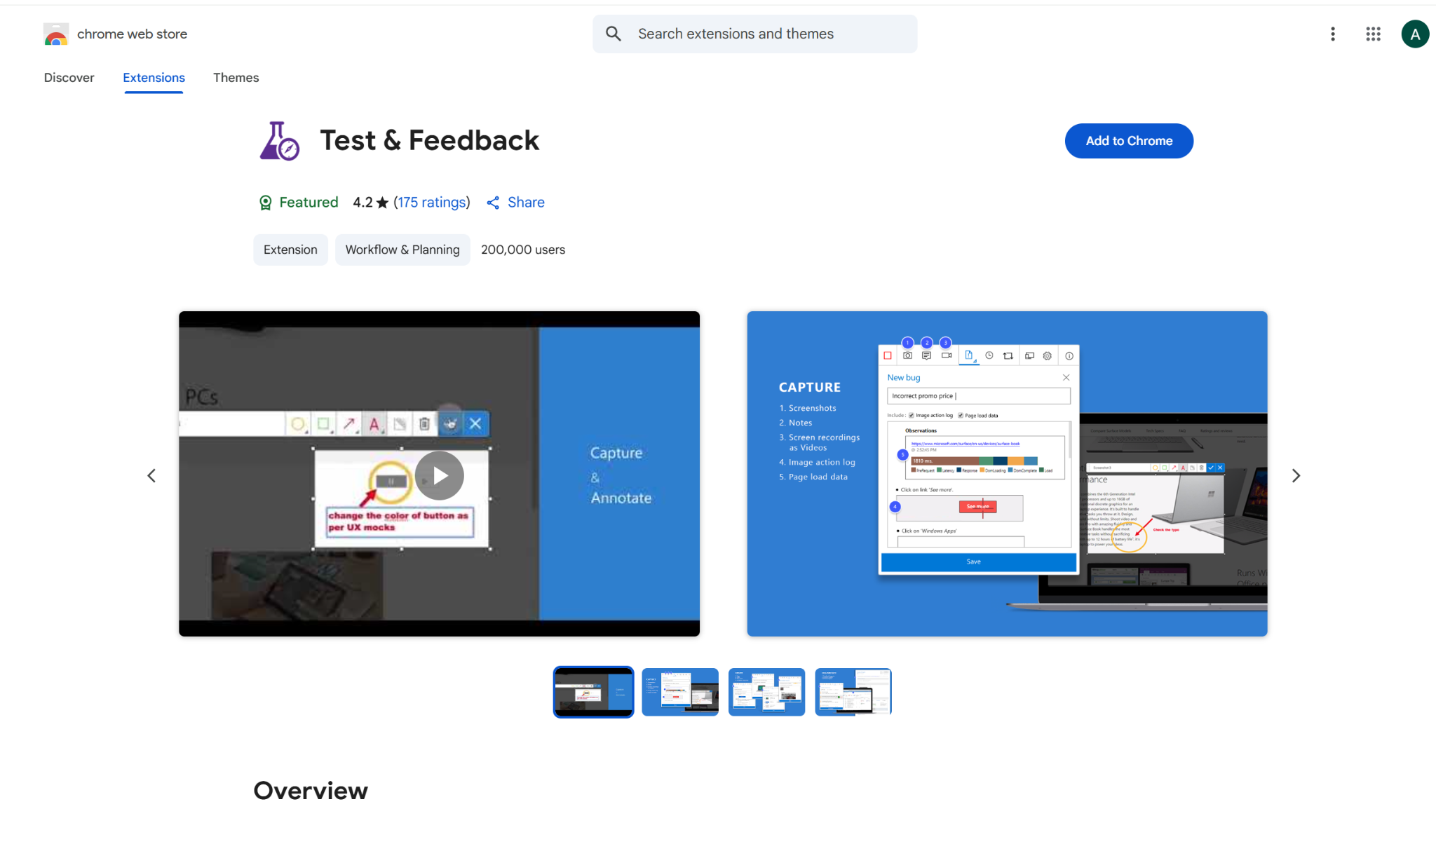

Showing it as an extension

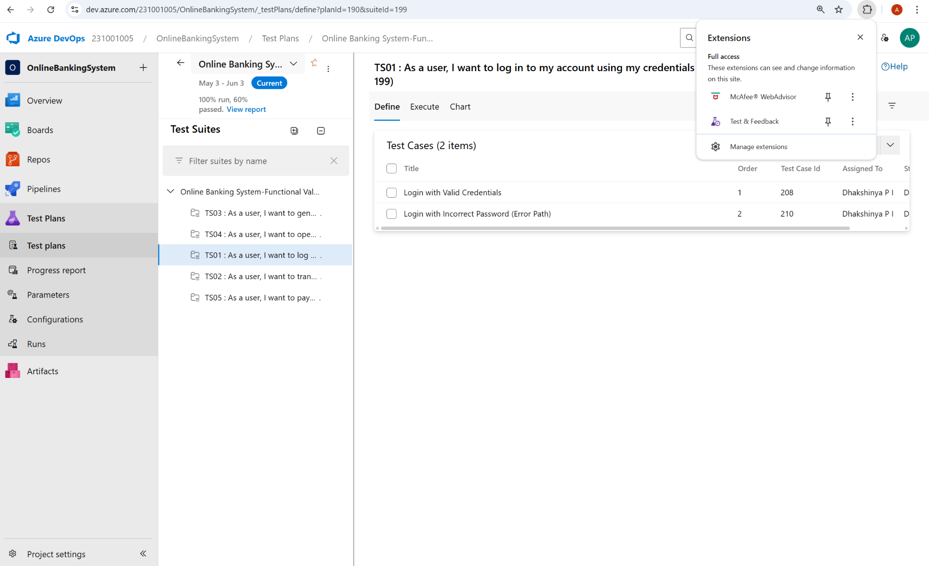

**5.Running the test cases**

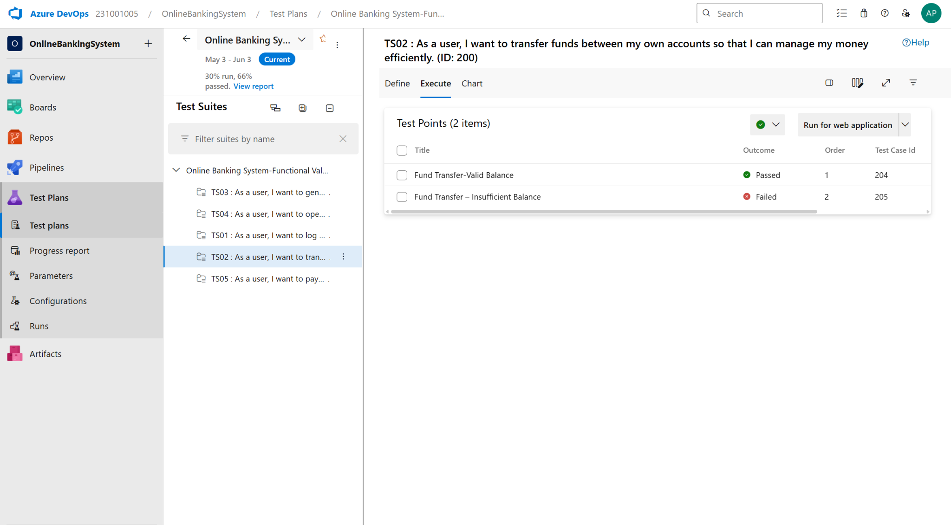

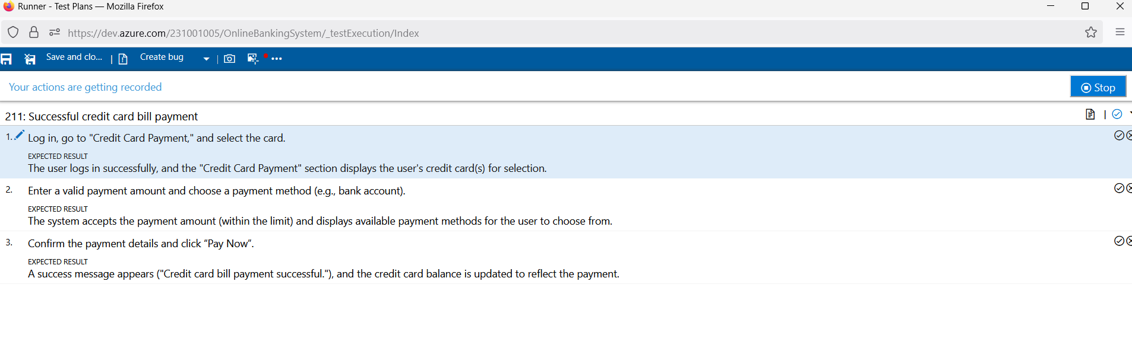

**6.Recording the test case**

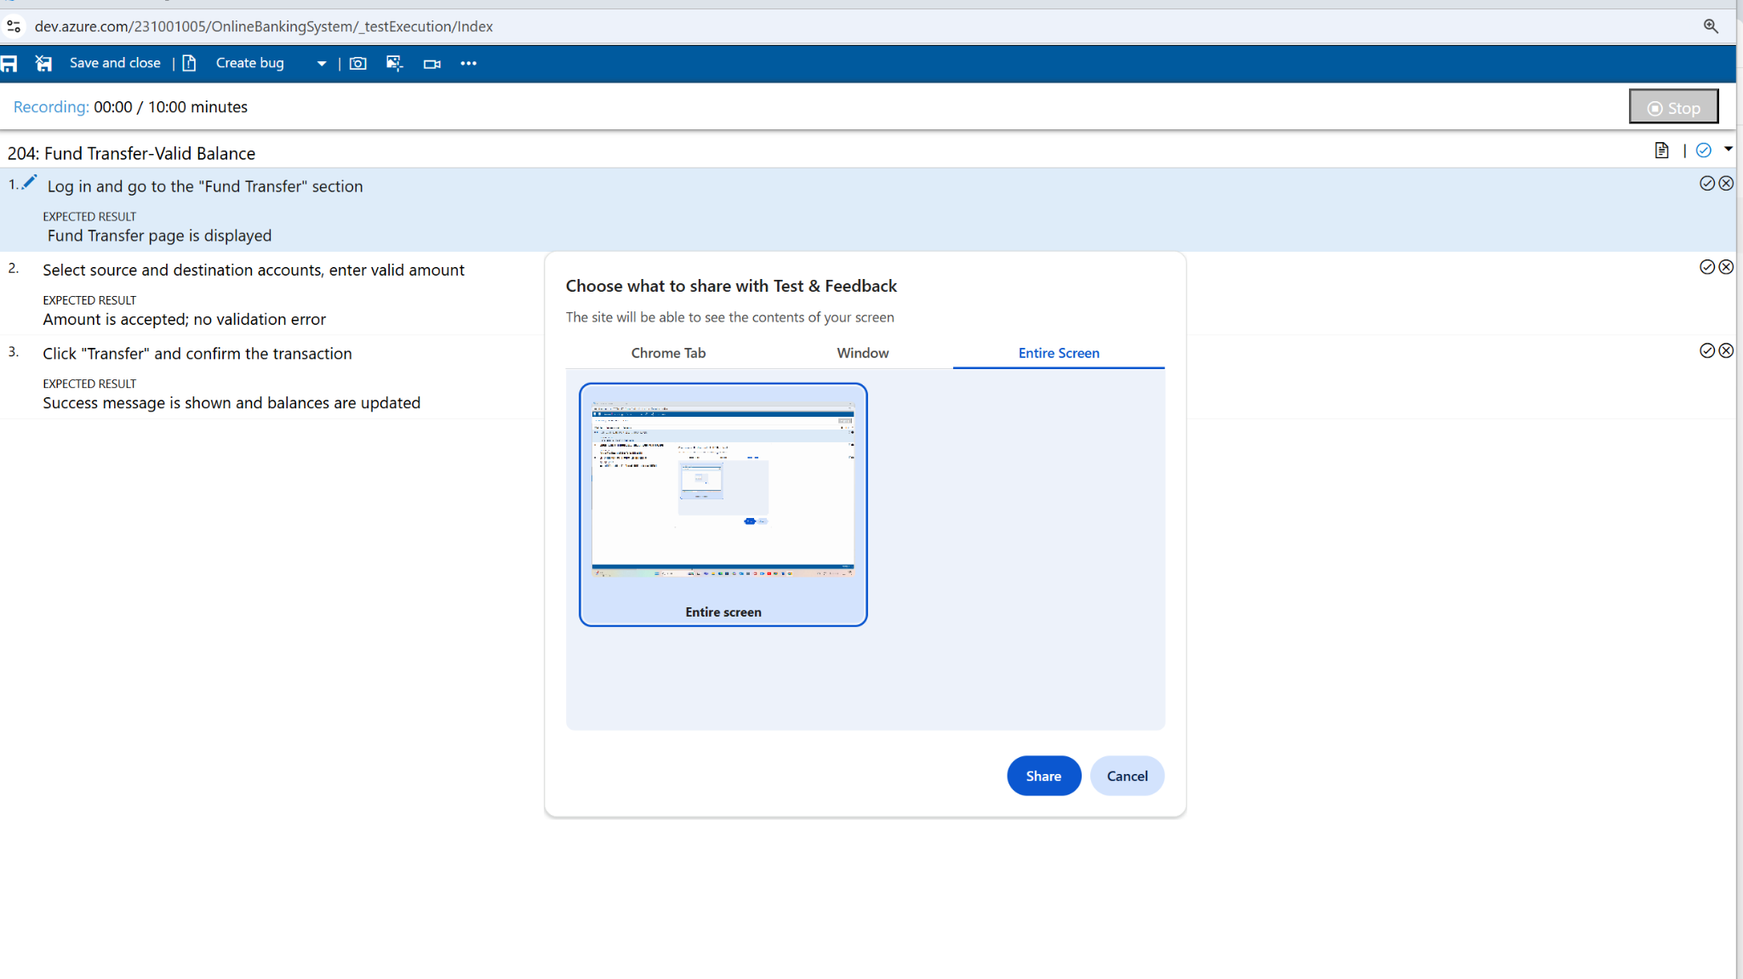

**7.Creating the bug**

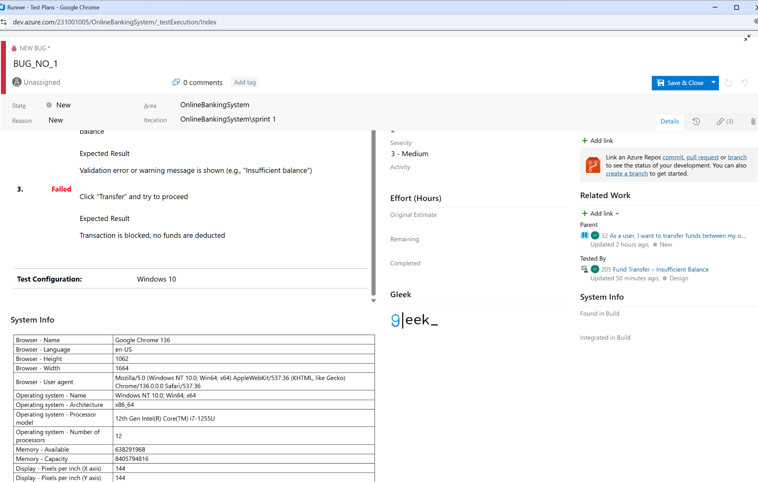

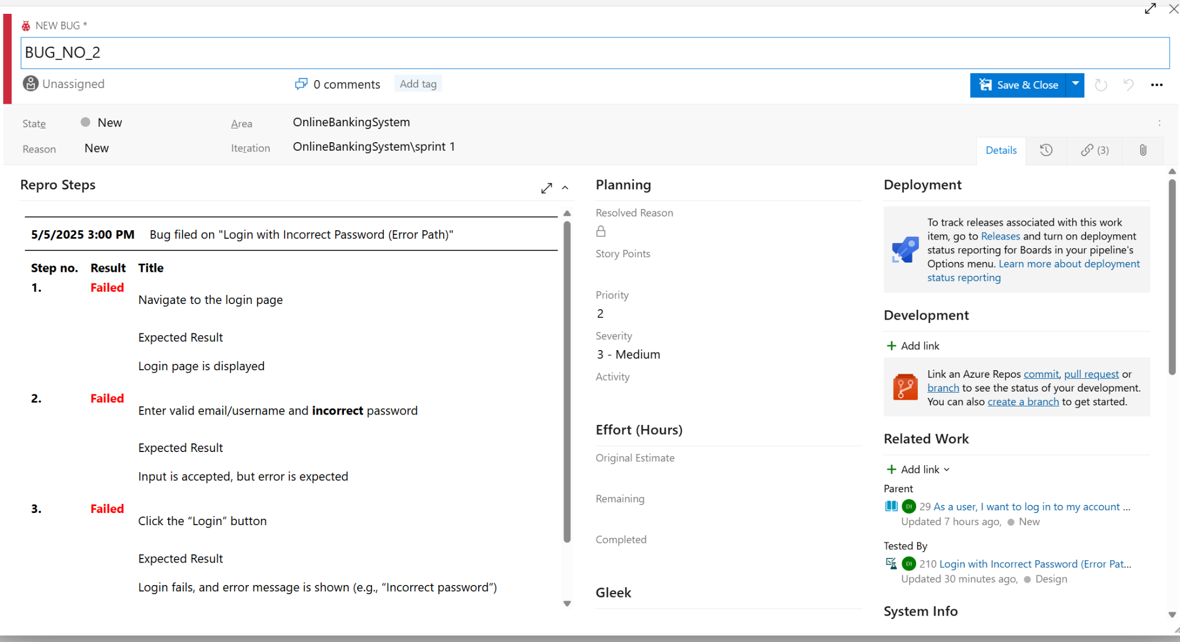

**8.Test case results**

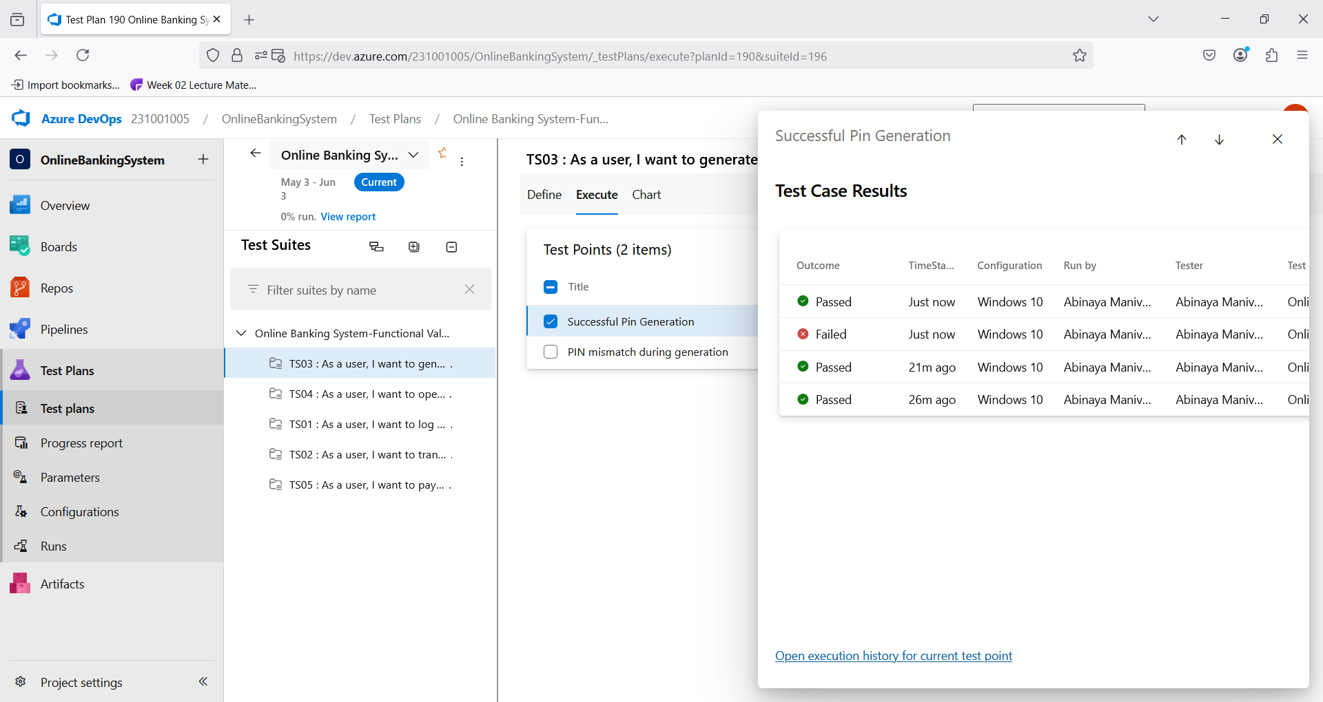

**9.Test report summary**

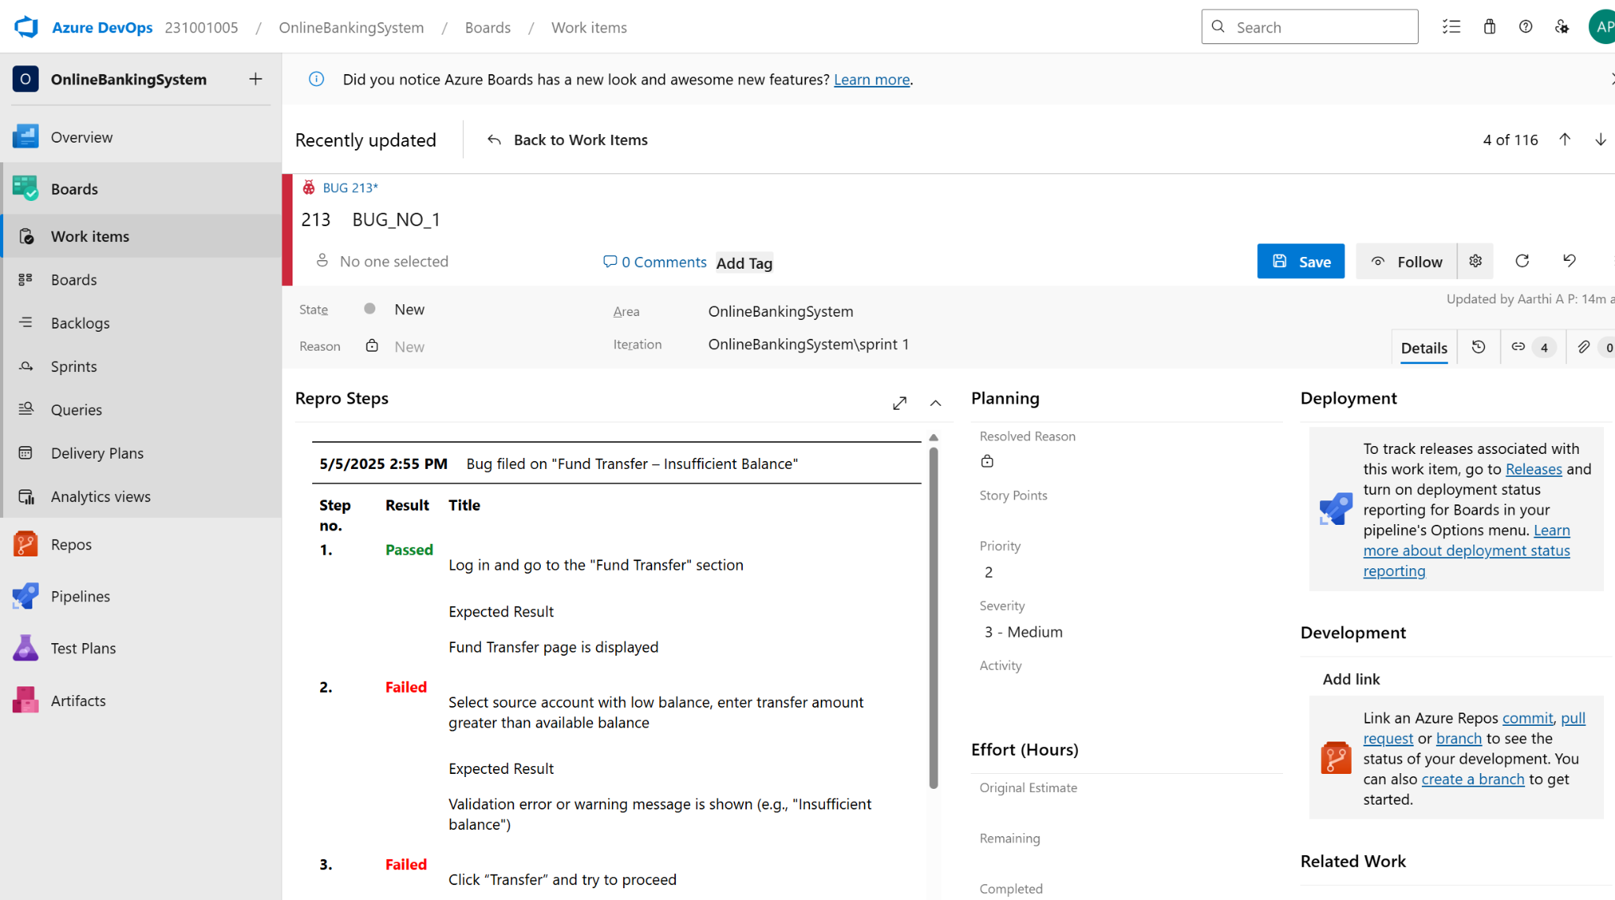

• Assigning bug to the developer and changing state

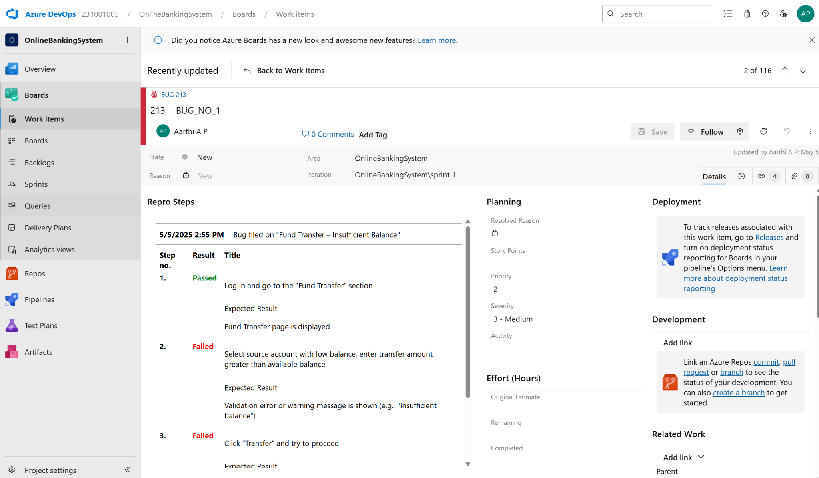

**10.Progress report**

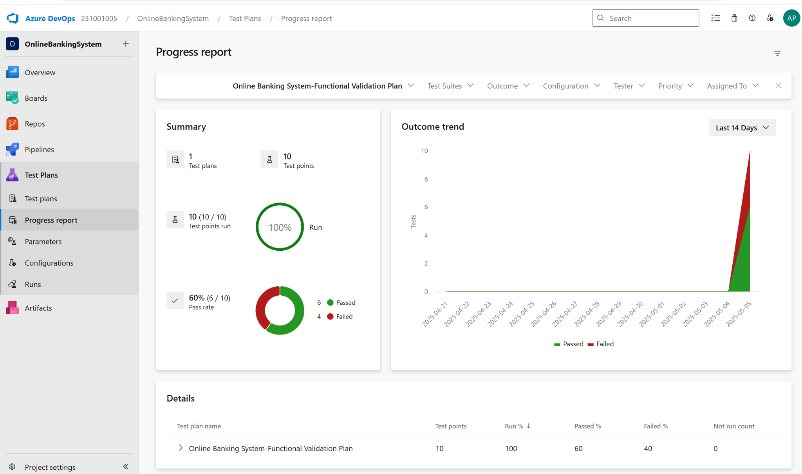

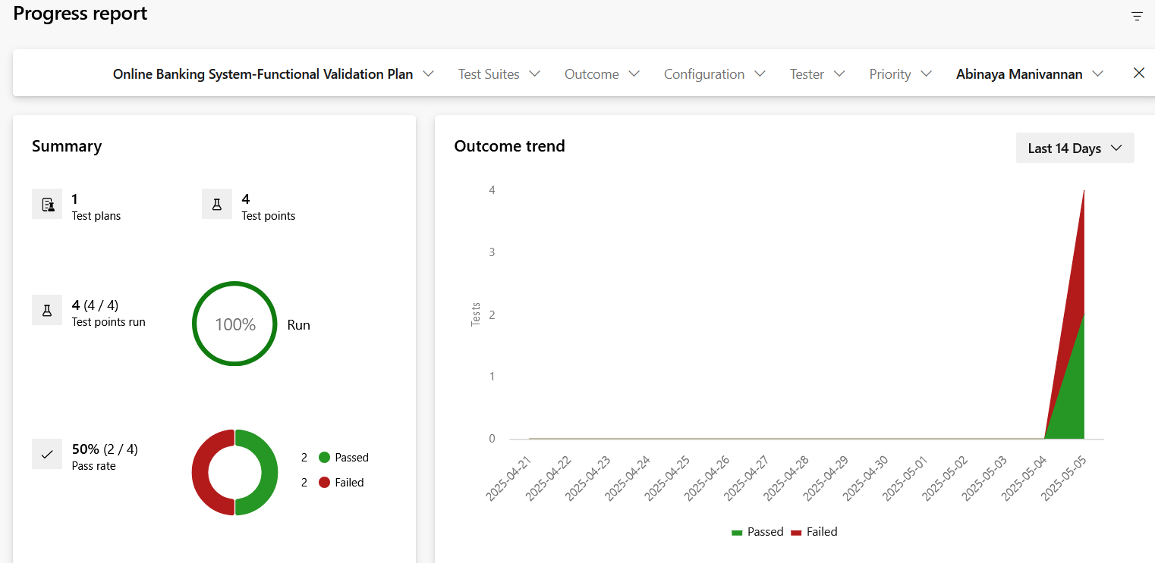

**11.Changing the test template**

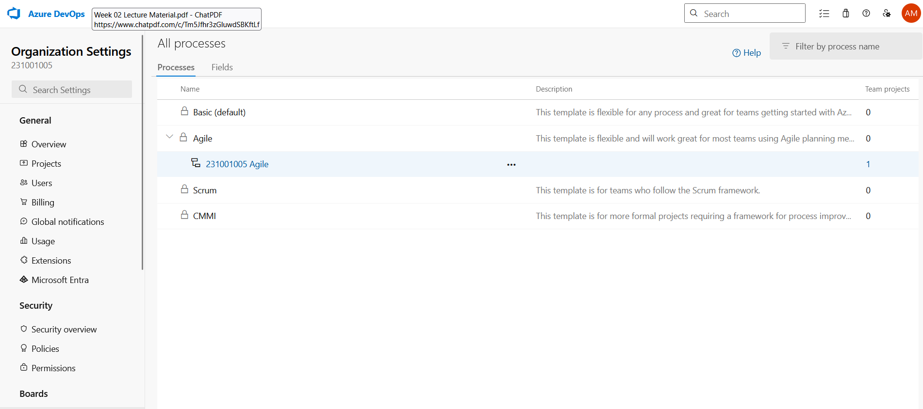

**12.View the new test case template**

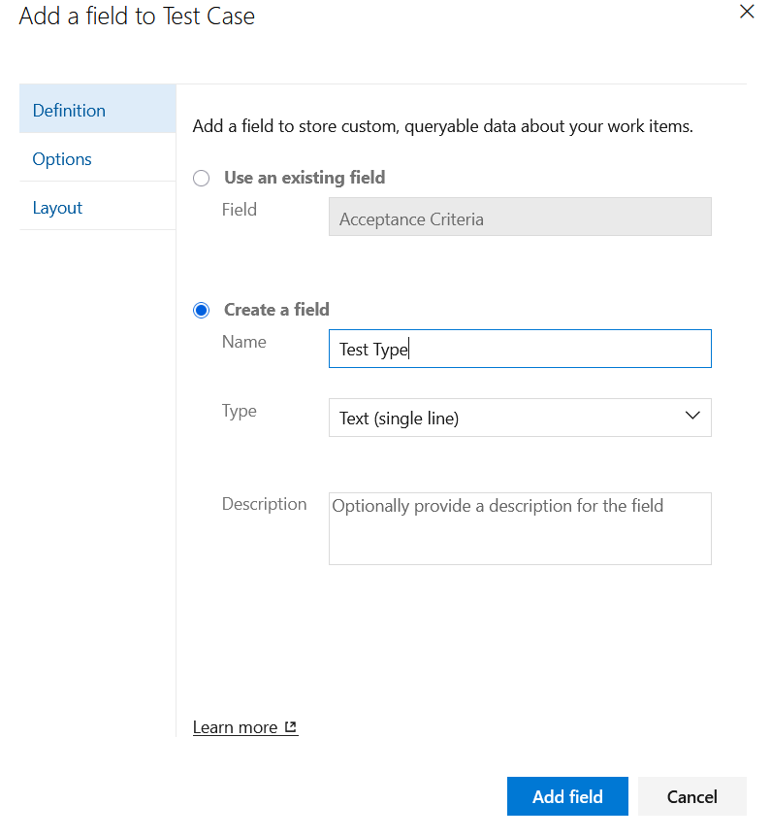

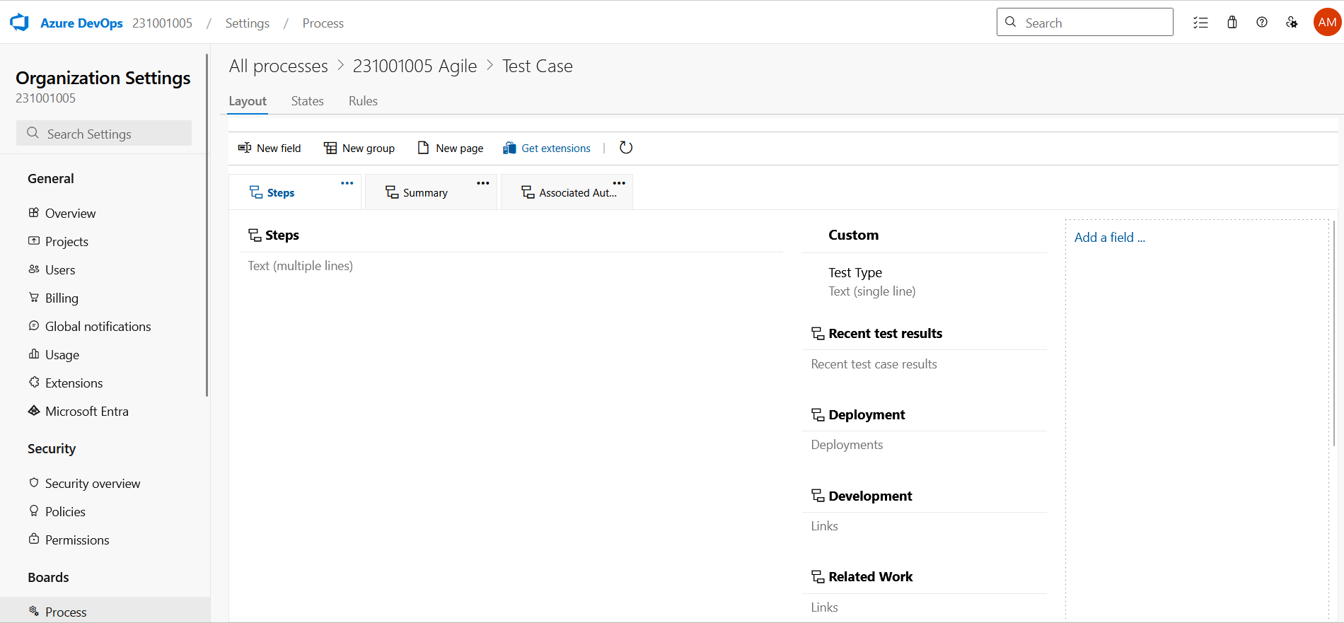

**RESULT:** The test plans and test cases for the user stories is created in Azure DevOps with Happy Path and Error Path

| **Exp.No: 9** | **LOAD TESTING AND PERFORMANCE TESTING** |
| --- | --- |
| **Date: 25/04/2025** |

**AIM:** To create an Azure Load Testing resource and run a load test to evaluate the performance of a target endpoint.

**LOAD TESTING**

**Steps to Create an Azure Load Testing Resource:**

Before you run your first test, you need to create the Azure Load Testing resource:

1. Sign in to Azure Portal

Go to [https://portal.azure.com](https://portal.azure.com/) and log in.

1. Create the Resource o Go to *Create a resource* → Search for “Azure Load Testing”.
   * Select Azure Load Testing and click Create.
2. Fill in the Configuration Details

o Subscriptio*n:* Choose your Azure subscription

o *Resource* *Group:* Create new or select an existing one.

o *Name:* Provide a unique name (no special characters).

o *Location:* Choose the region for hosting the resource.

1. (Optional) Configure tags for categorization and billing.
2. Click Review + Create, then Create.
3. Once deployment is complete, click Go to resource.

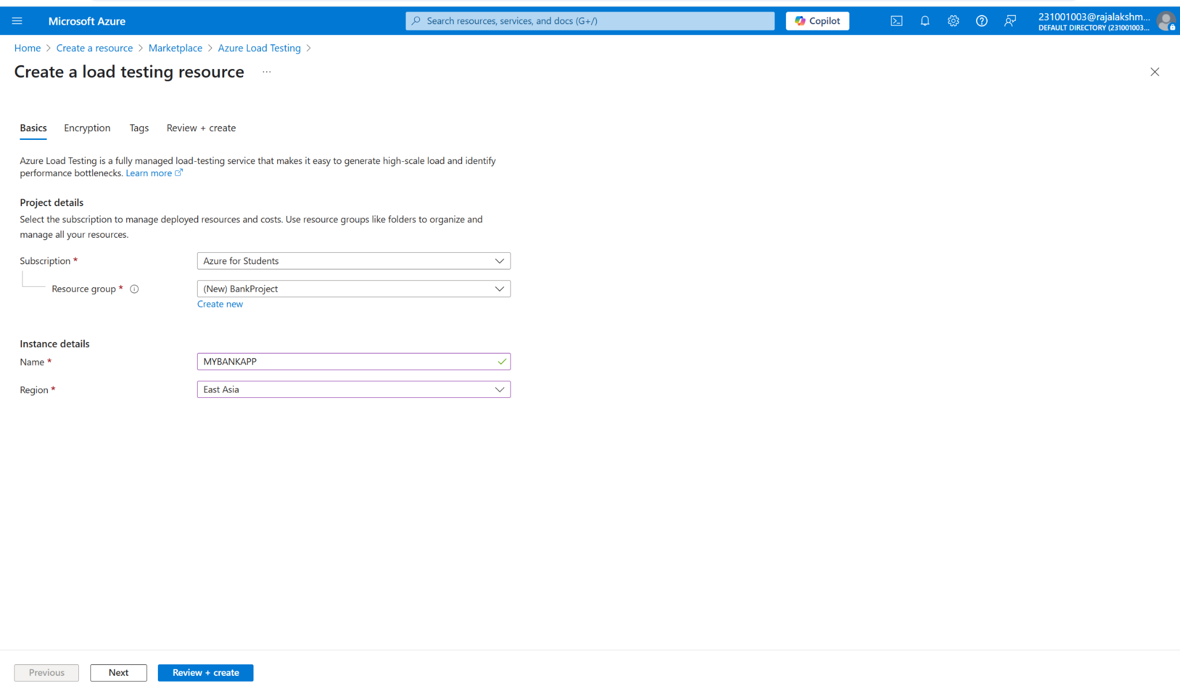

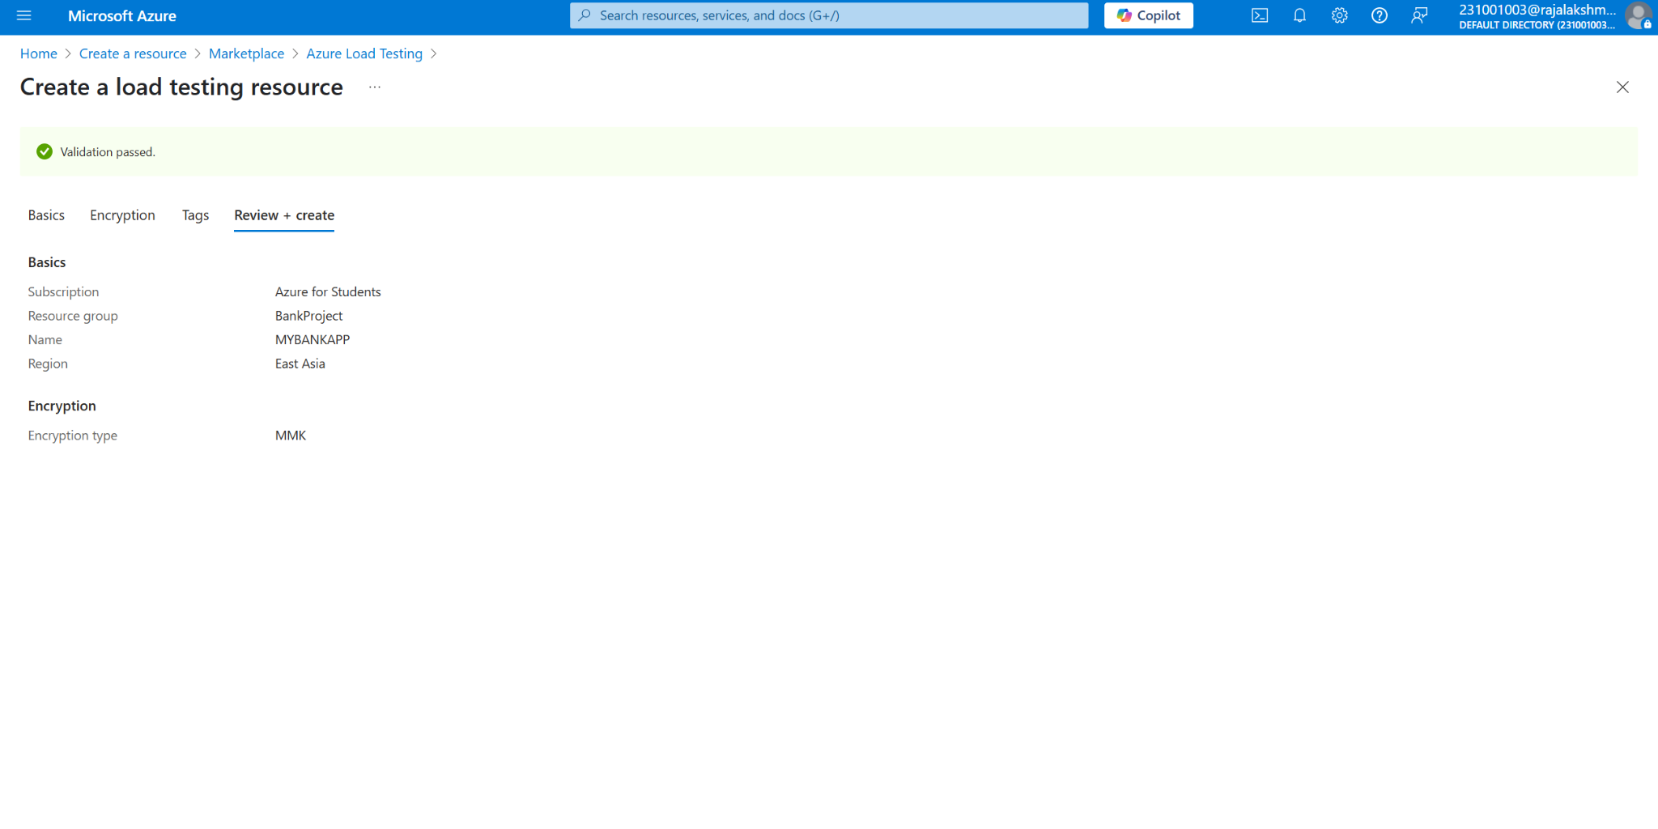

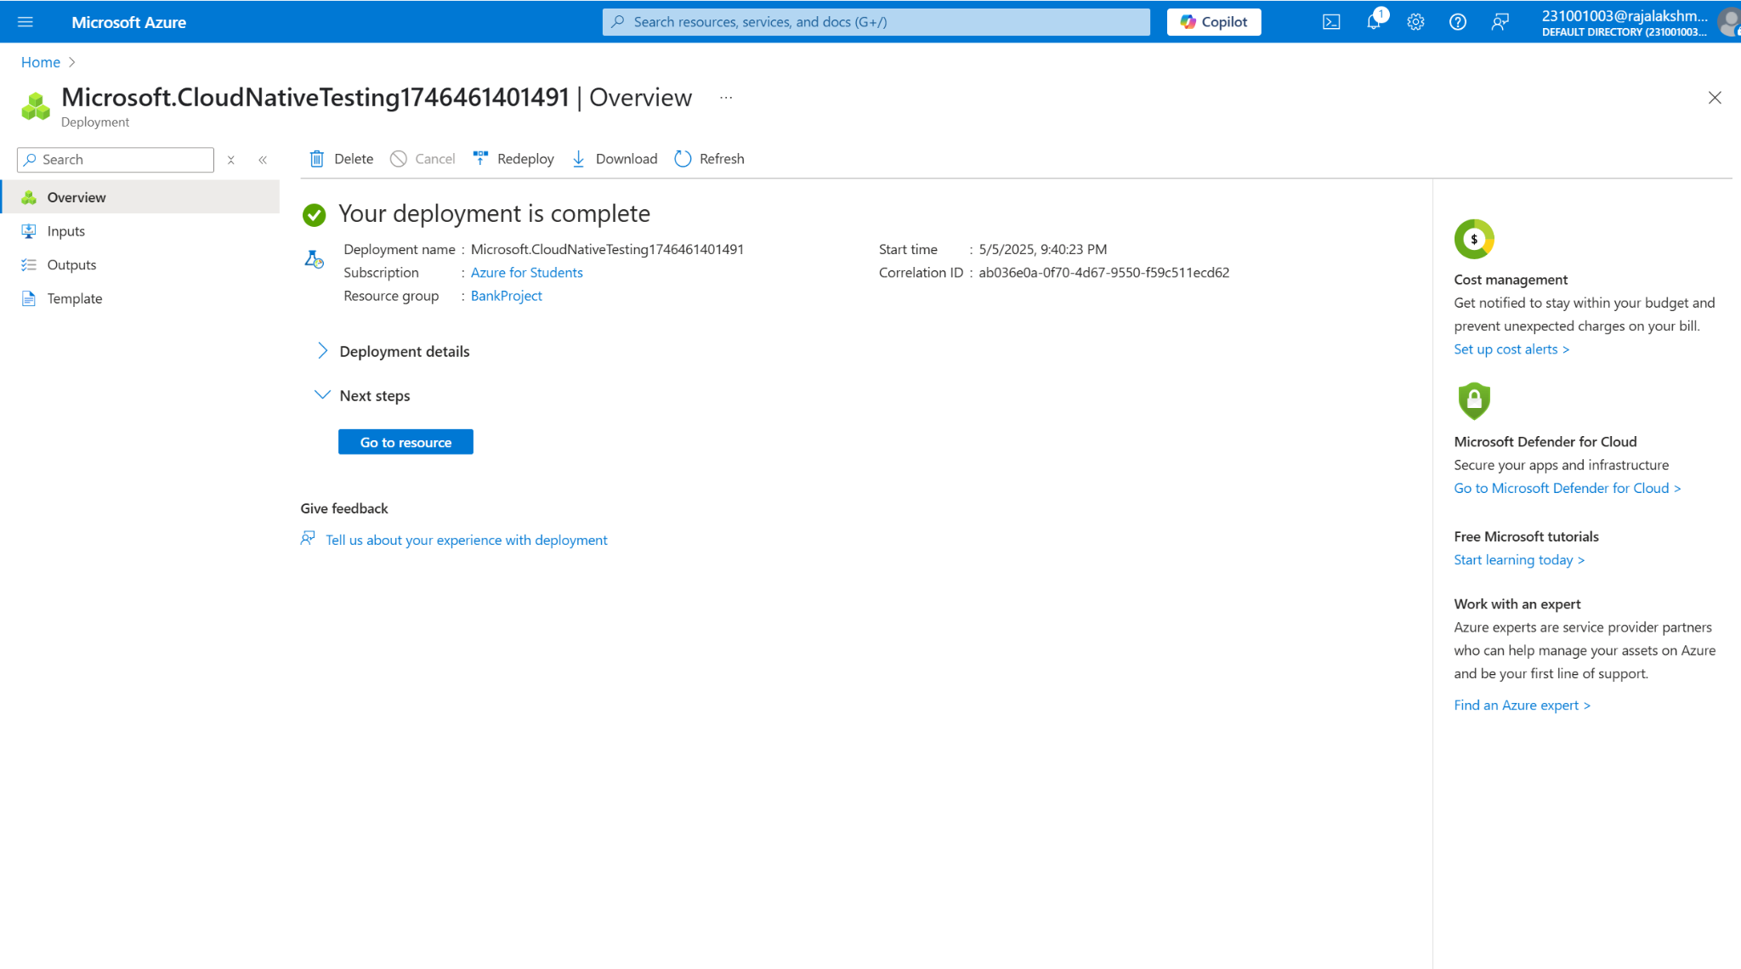

**Steps to Create and Run a Load Test:**

Once your resource is ready:

1. Go to your Azure Load Testing resource and click Add HTTP requests > Create.
2. Basics Tab o *Test Name:* Provide a unique name.
   * *Description:* (Optional) Add test purpose.
   * *Run After Creation:* Keep checked.
3. Load Settings o *Test URL:* Enter the target endpoint (e.g., https://yourapi.com/products).
4. Click Review + Create → Create to start the test.

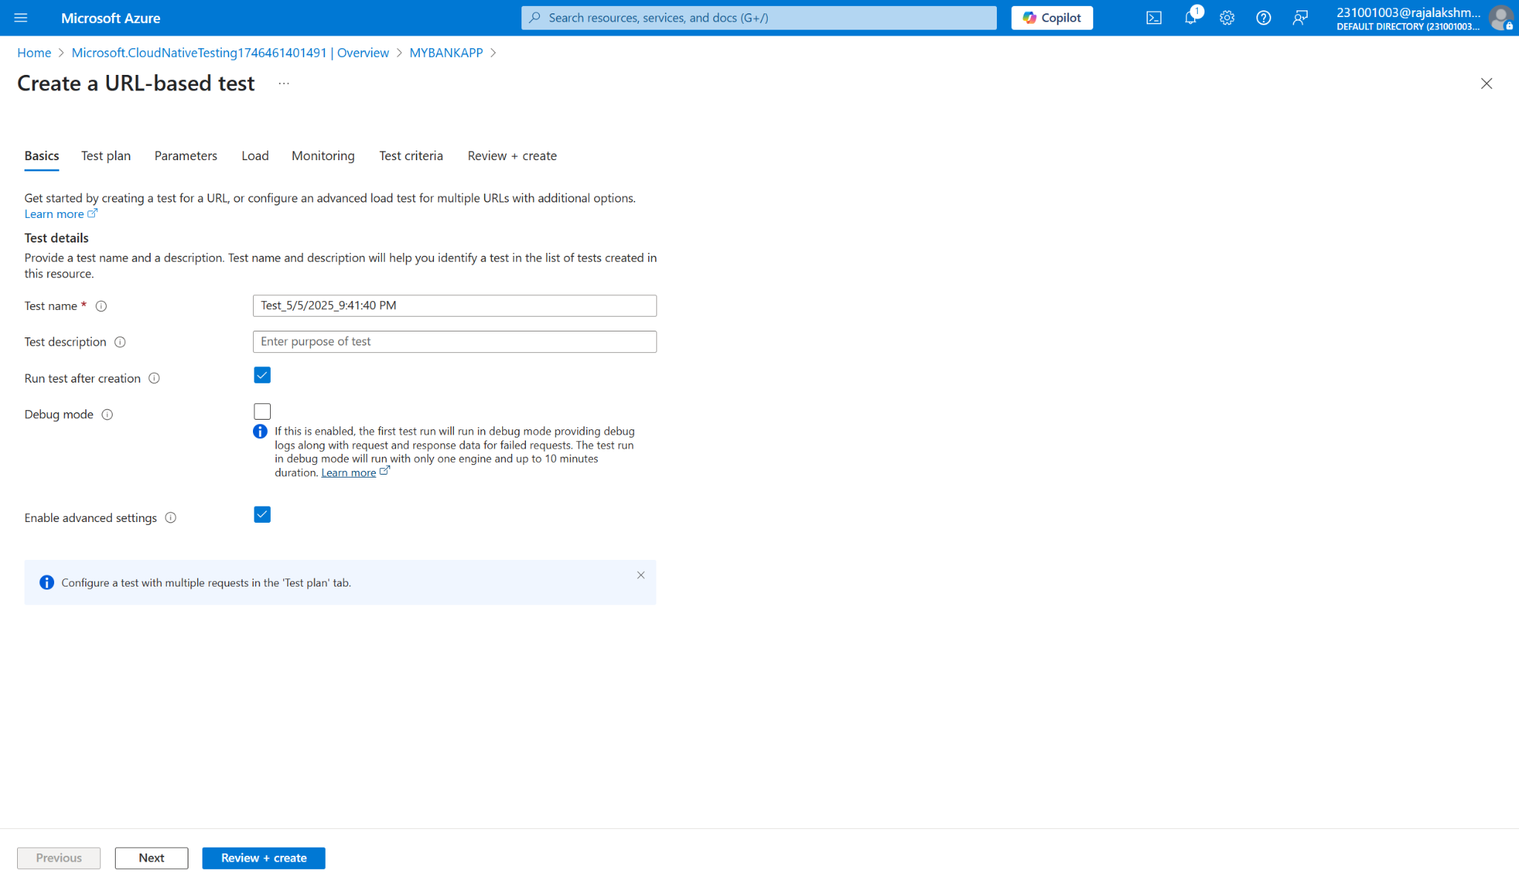

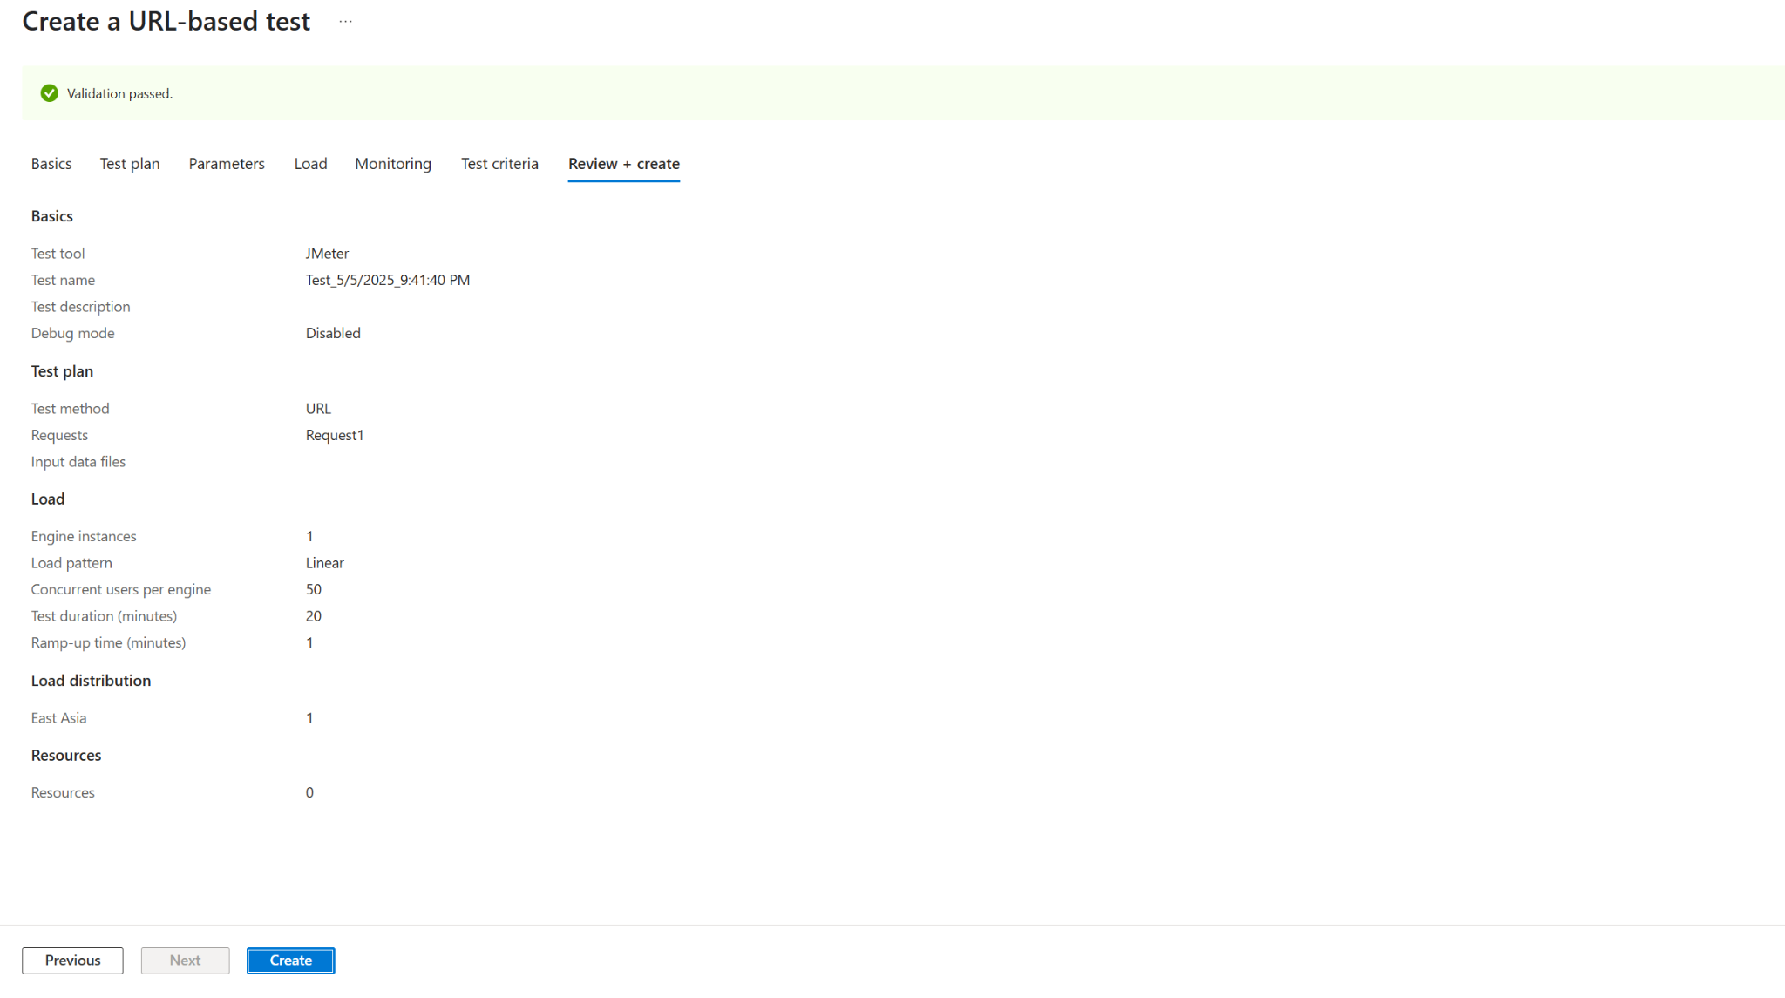

**Load Testing**

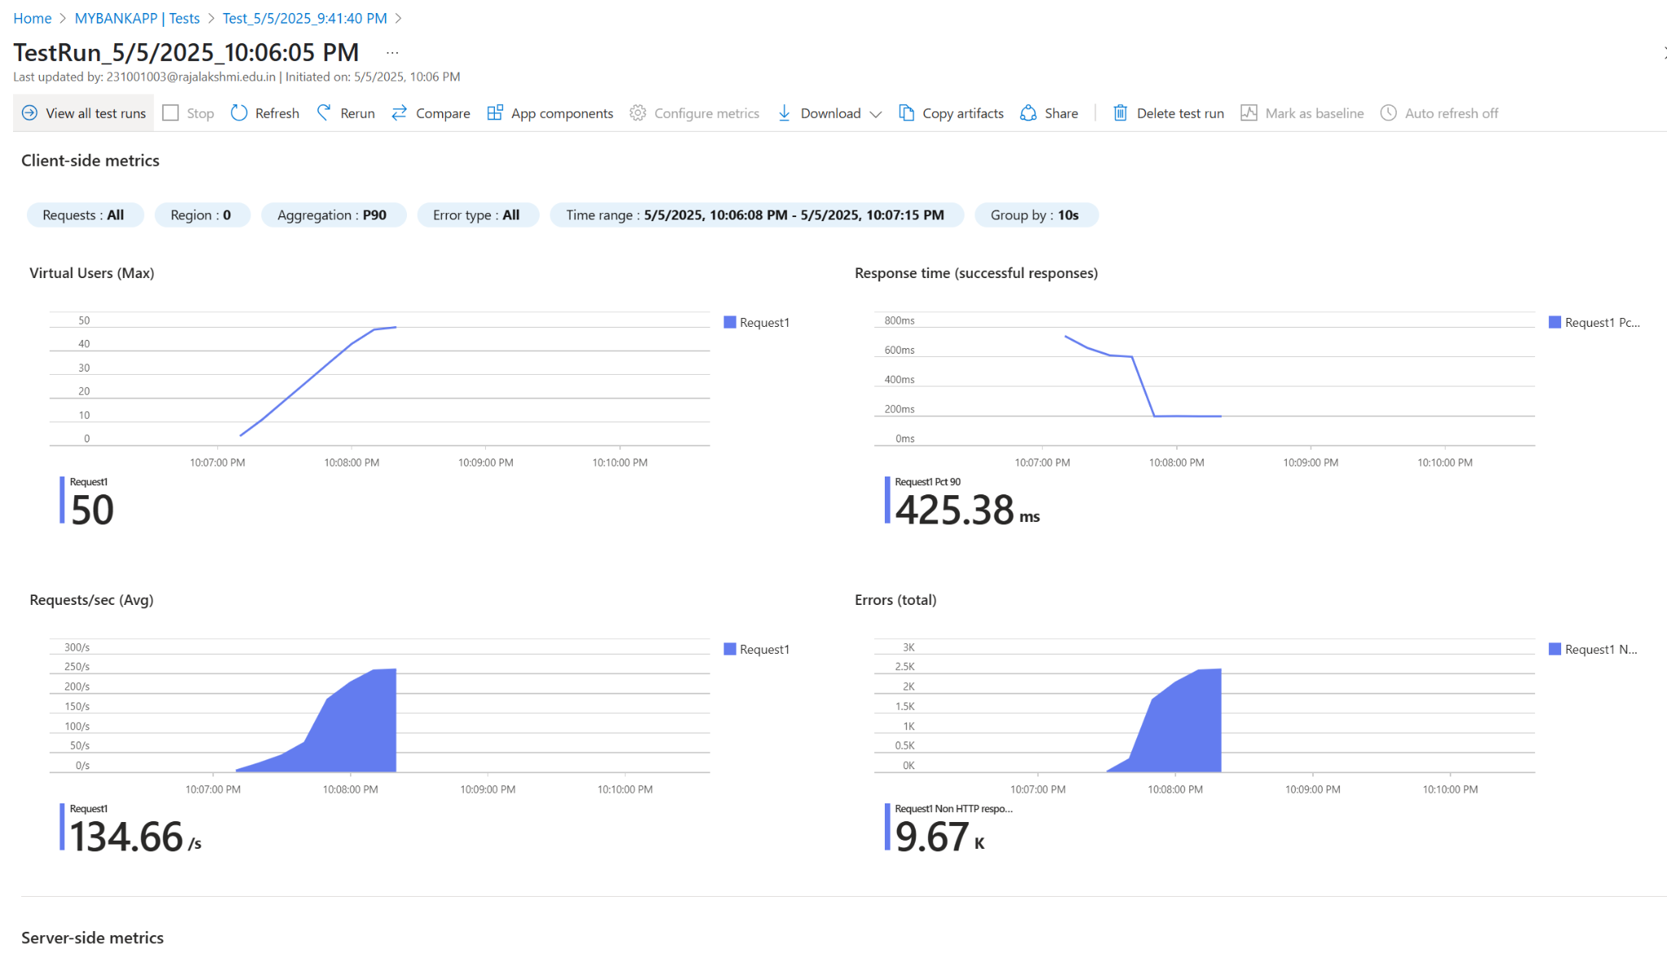

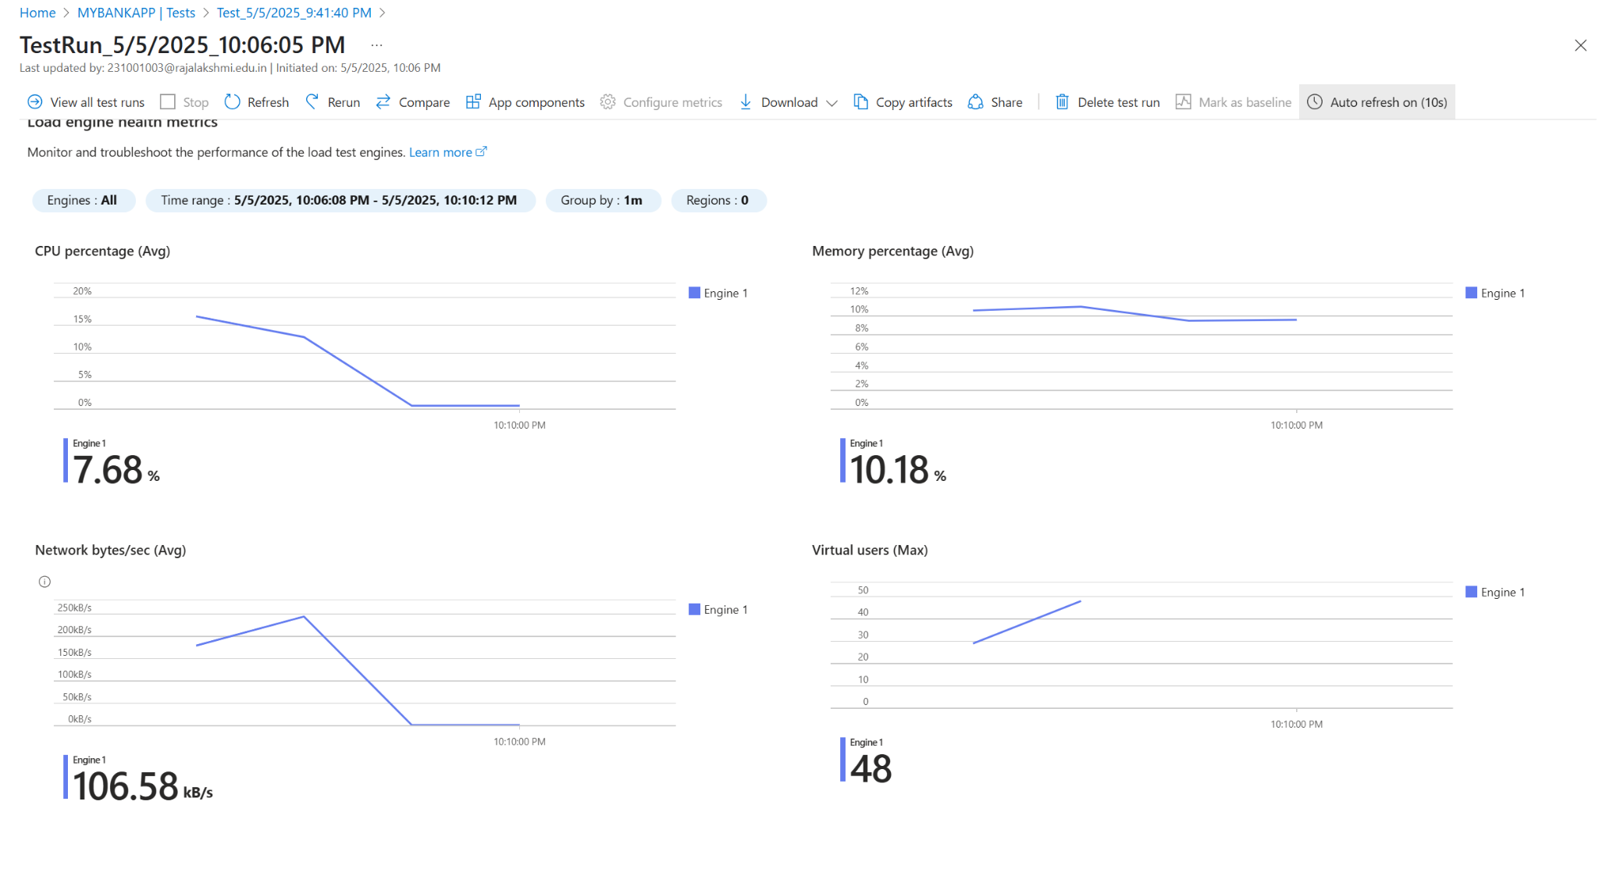

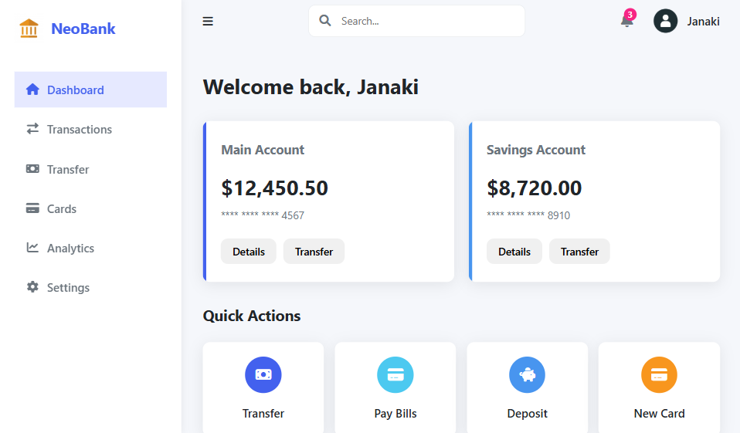

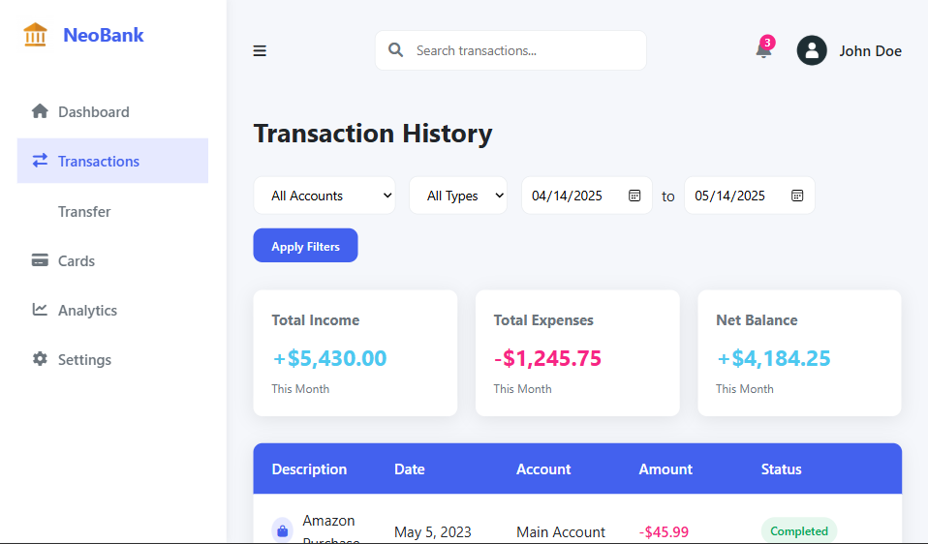

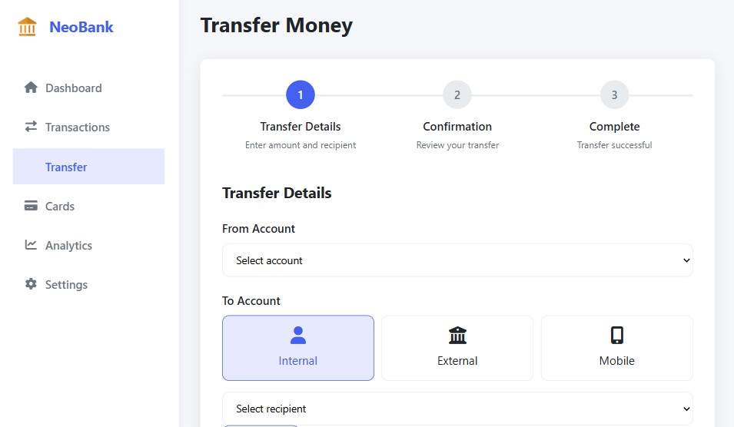

**RESULT:** Successfully created the Azure Load Testing resource and executed a load test to assess the performance of the specified endpoint.

| **Exp.No: 10** | **GITHUB PROJECT STRUCTURE & NAMING CONVENTIONS** |
| --- | --- |
| **Date: 02/05/2025** |

**AIM:** To provide a clear and organized view of the project's folder structure and file naming conventions, helping contributors and users easily understand, navigate, and extend the Online Banking System project.

**GITHUB PROJECT STRUCTURE**

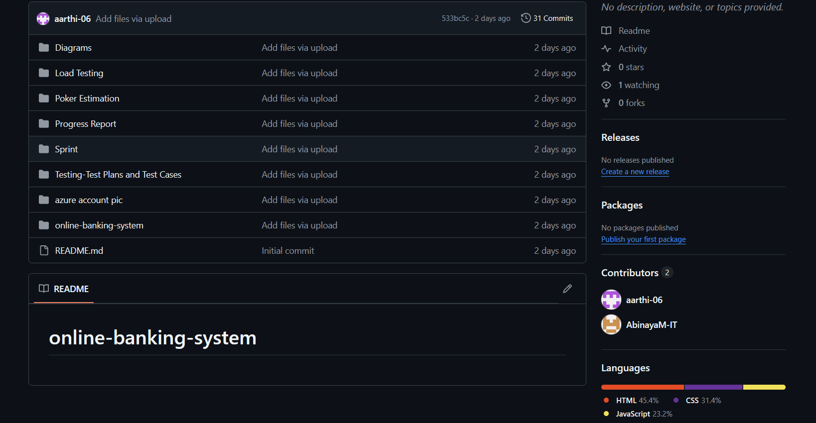

**RESULT:** The GitHub repository clearly displays the organized project structure and consistent naming conventions, making it easy for users and contributors to understand and navigate the codebase.